Owen Cup Final
Barton 25 - 6th May 2012
Who were the opposition on Sunday ? I know they didn't score any points. I know they didn't boss us about up front, I know they didn't harry our backs, I know they didn't test our full back with Garry Owens, I know they couldn't stop Shum cutting inside and cutting them up, even if he as the one with stitches in his head at the end of the day. I know they couldn't keep possession at the rucks and I know they couldn't take any advantage of the time they spent on our five yard line. I know they were confused with Bird and Maxwell kicking to the corners, and I know they were confused when Bird and Maxwell kicked grubbers through the middle. I know they were thankful that Matt Cox couldn't collect the grubbers, and I know they were very thankful when one of our lineouts went wrong - it was the only of of the day and I know Bobby Ball was surprised to see them win the ball because he knocked it on. I know how upset he will be with himself about that. I know big Simon Scott says that's his last game, but I know that he won't be pleased that James Thorpe stopped him in his tracks every time, and I know Thorpedo is half his size.
I know Birdy was out to impress Farmer Vic and I know we cheered loudly when his first penalty soared straight over from in front of the stands. I know she was impressed. I know we had the best set of WAGs too;
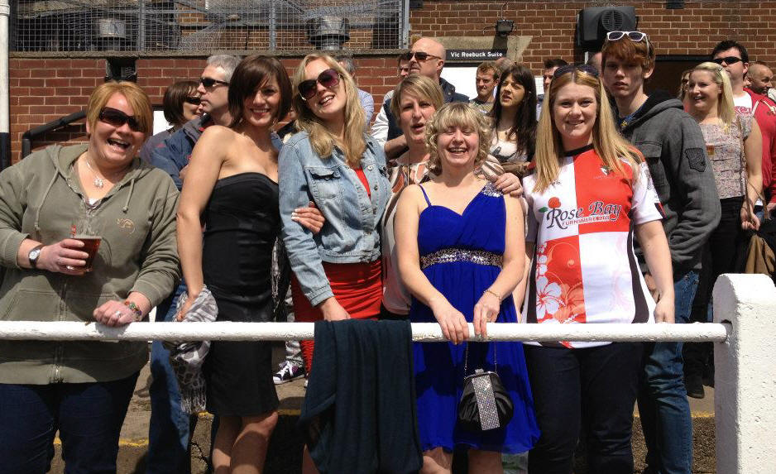
I know the big pack from out west thought they would dominate the scrums and I know they were upset when we pushed them off their ball on their 5 yard line. I know Lee Coton was never going to crack under pressure and a neat pop to Pow Pow led to the first try. I know why the Cannock faithful were silent, and when Birdy made the difficult touchline conversion I know we were on a roll. Being The Count, I know numbers, and at half time I know we were 10-0 up. I know that last year Cannock were 10-0 up and I know they went on to lose. I also know we can learn from history.
I know that Red & White is a better combination than Blue and Yellow - disagree ? Try this sentence : "Her flame hair flowed beautifully over her alabaster skin." See ? It doesn't work with Blue and Yellow does it ? Red & White are the perfect combination. I should know.
I know that on a sunny day on a pitch like this, our backs have a great day. Spin, spin, spin and Cleary ends up with the ball. Ducking, darting, I know he doesn't muff opportunities like this and he knows where the try line is - he was going to score. He did. Of course the Burton supporters told me it was due to the training he had in Burton Colts. I gave a knowing smile. Birdy had put over an earlier penalty and I know this adds up to 20-0, and I know by this time the complimentary Pedigree was having an adverse affect on my balance, speech and ability to focus, but I did know it was all good.
I know the game was out of reach and I know the opposition wanted to go home (did they ever arrive?). I know the sun got a bit hotter and the beer a bit cooler as Kev rolled on the subs. I know a game this season would not be complete without a try from Shum, and it duly came in the right hand corner in front of the bar. I know Matt Bayley (new shorts) and Tom Robinson (old shorts), with the help of Rowe, MBUK and Palin had made sure the rucks and mauls were Barton's and I know this dominance gave our backs confidence to stay out wide. Jonny Simons carried the ball up again, and the ever impressive Wooly came in off his wing to take the ball further. I know Quidditch was excited to play in yet another final and I know his mum would be proud of the space he saw for the winger to abuse. I know Grant Clissold was unhappy not to take a straight crash ball into the quivering centres, and I know those same centres were happy he didn't. I know Birdy missed the conversion, but I know it didn't matter.
I know Myles, Cliffy and Jody were sad not to get on the field but I know they are very proud to have been part of the squad to retain the cup. I know Danny Carlins was unhappy they spelt his name wrong in the match day programme, but it serves him right for leaving his stuff in the Shoulder and expecting me to carry it to Burton for him.
I know we won the cup again. What a way to send Matt Cox off to Canadia. I know he will be missed.
I used to know Cannock, but I don't now. But I do know that Barton played their best Rugby ever on Sunday and if one more person says to me "You should be playing in a much higher league" I know I'll smile. I know I will. Again.

Barton 57 - Tenbury 22 - 24th March 2012
Waiting for a match report but pictures speak a thousand words (If only I knew that during my English 'O' level)
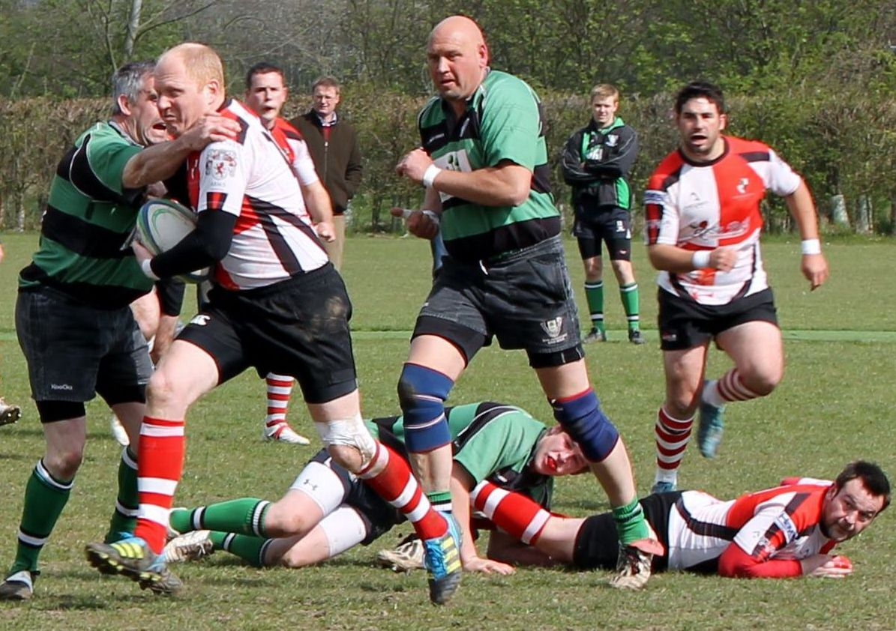

Market Samoa 53 - Barton 0 - 24th March 2012
Well I don't know what happened but we lost. I've not seen these guys in Market Drayton before though:
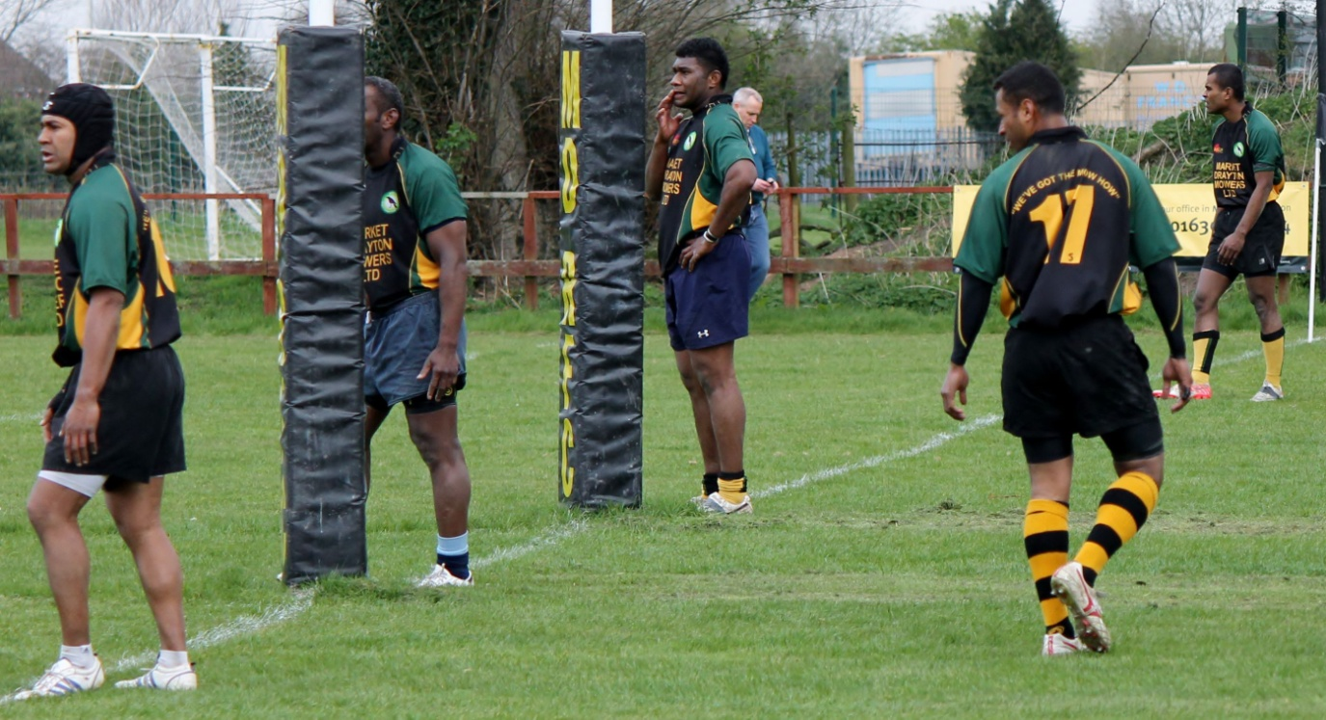

Barton 73 - St Leonards 0 - 17th March 2012
Well I don't know what happened but at one point we were down to 13 men (AGAIN !!!!) but still won convincingly.

Barton 31 - Edwardians 23 - 17th March 2012
There are times when you just need to be there. To show support. To show solidarity. Even in the face of adversity.
Edwardians were top of our league, had played at much higher levels a few years ago, trounced us 53-3 in our last encounter, had a vast array of international shirts adorning their club wall, and had played at Twickenham last season.
This weekend was supposed to be free. I had planned a day watching Six Nations games and drinking beer, but instead we had a rearranged home game against the league leaders. I had just driven up from Heathrow after a turbulent overnight flight from Texas and the Starbucks coffee had not jolted me into life. I was tired, dishevelled, and the last thing I wanted to do was to watch Barton get beaten, but they needed, nay, deserved our support and I had to be there. Drawing into Holland Sports Club realised I'd left my coat at home, and thinking of the challenge our boys faced at 3PM I tramped forlornly across the cricket pitch, pensive about the next 80 minutes, then, just as I reached the touchline it started to rain.
But wait a minute. This is Barton. We have always played our best rugby at home. We have a tenacity, grit and determination that has a Scottish flavour about it, and a team ethos that is envied by others in this league. The touchline was packed with like minded men and a bevy of beautiful women, all behind their favourite team. Yes, in East Staffs, the red & white quartered shirt actually means something, and as each and every player crosses the whitewash, a steely glaze comes over the eyes and we cannot wait until the whistle blows.
We saw the same ten / fifteen years ago when we wore heavy cotton shirts, no padding, thick socks, and the start was often delayed as the referee did a stud inspection. But ten or fifteen years ago we use to wait 20 minutes before starting to play. John Shum never saw this "tactic", and, as last week, he took the ball and within 4 minutes we were 7-0 up. Edwardians reorganised and put their powerful black winger on the left. He we phenomenal against us last encounter and racked up 4 tries, and is an impressive a winger as I've ever seen. Strong, good lines of running, and very good positional knowledge, working well off a pair of experienced centres. He was given lots of space out wide as Shum played tight with Jan Cleary, but Shum's unconventional tackling technique (head in the belly !!) kept him pinned to the touchline.
Grant Clissold played a fantastic game off Birdy all day. Quidditch was given instructions to get quick ball from the set piece and breakdown, and true to Kev's word, the ball flew out quickly 100% of the time. Birdy passed 75% of the time and Edwardians had little to offer to stop Sonny Bill Clissold as he thundered into the inside centre and openside flanker every time (it always took two to tackle him). Jan and Pow Pow were always on hand to offer alternatives left and right, and with the fragile tackling of the opposition standoff, the ball was often recycled inside. I've just described how we scored our second try and as Pow Pow neared the line he decided to pop the ball out, but the pop was a loop pass that gained more height than many of Barton's drop goal attempts. As we waited for the ball to come back into the troposphere Wooly waited patiently knowing he was about to score. The ball came down and he did. Edwardians managed an unconverted try but we were 14-5 up and dominant.

But then things started to change. The excellent referee pinged everyone who didn't release quickly enough, and at this level, that meant everyone so there were a lot of penalties. Two were converted and it was 14-11. Edwardians were slow to recycle ball and we were quick to react; often too quick and Pow Pow and Thorpy on the flanks were seen to be fringing a bit too often. I once played in a game where the openside proudly told me he neither gave away any penalties, nor got a talking to from the ref. He did get a slap from me because in my mind he wasn't doing his job. Our back row were up quick and snuffled any suggestion of a break through the tight. The sloth like feed from the Edwardians scrum half made it look like we were offside all the time, and Pow Pow got a bit of a talking to for being too keen. The standoff hated it because the only ball he got came with a complimentary flanker - Gilbert and Thorpe. The Edwardians Coach told me that Pow Pow was offside because Jonny Simons was so far back but at the next breakdown he spotted our tactic of sending up a Spear and leaving the rest of the defensive line intact. Sadly the referee decided this spear was too quick and decided the next infringement would collect a Yellow card; it was Rowie, and five minutes before half time and we were 14-11 up but down to 14 men. Jonny and Coxy rallied the troops.
The team was awesome. As you go through the team sheet there were a lot of comments like "he had a quiet game", but isn't that what you want ? Sam Murphy had a quiet game. He came into the line when you wanted him there, he was back covering when you didn't. He caught balls that were in the air and marked them when needed. He ran with the ball from defence when you wanted him to and kicked the ball to touch when you didn't. He had a quiet game?! Great. The whole team were in "quiet mode" - do your job, do it well, support your team mate. As in the old days, when you're a man down, everyone has to play as if they are covering two positions, but never give up. We didn't, and the frustration of the opposition was clear because they expected to score many points with or without a man advantage. With the help of their very active Full Back who came into the line and stood up Jan Cleary, an overlap was made and protected and they went over in the corner for a try. It was not converted but the celebrations from scoring were unseemly but a big relief for the visitors. They were 14-16 up and Pow Pow had infringed once too often and was yellow carded too. We were losing to the league leaders, we were down to 13 men, there were no touchline nibbles and the mood was sombre. It started to rain again.
We dug in. We dug in hard. Very hard. No wind, no creases in the flat line defence, just a knowing smile. The crowd were vocal, supportive and utterly silent during kicks, and as belligerent as the players. The Pack were wonderful and knew that with two forwards down it was going to be tough up front. We brought on Dave Palin for an exhausted Mikey Bennett, and the game rolled on. The lineouts were not working well for us today but the scrums were very solid. Tom, Bayley and Cox were a match for anyone in this or any other league and even the Ed Jessel like opposition hooker had nothing on us.
A knock on, a scrum in their 22, A BBIIIIIGGGGGG push from the seven men and they went backwards and through 180. Jonny jumped up, pumped up and drove his forwards on. Quick clean ball, scissors with Grant, pop to Jan, back inside and there was Birdy under the posts. Thank you very much. Conversion 21-16.
The sin bin minutes dragged on for ever. We tried to run down the clock, and even puppy dog Quidditch didn't run for the ball when we were awarded penalties. Edwardians pushed us downfield with relentless running from their backs but could not free up their wingers or make big holes through the middle. I even caught their second row checking we only had 13 on the pitch - his frustration was clear. But eventually they were in our 22, parking their tanks on our lawn and we were defending a scrum. 7 in the pack, big effort and hope they don't break off quickly. We went backwards and collapsed the scrum. It was the first penalty in the red zone and I admired the decision making - run down the clock while you are out numbered, but be careful. The referee didn't agree and instead of awarding a penalty (which would have obviously been taken as another scrum), he awarded a penalty try. It was converted and we were down 23-21. As I said there were no nibbles on the touchline but everyone there had chewed their fingernails down to the quick, and was too tense to eat. We held our defensive lines, didn't panic and gradually came back to full strength as Pow Pow an Rowie returned. But we were still losing and there were 5 minutes left.
A good run from Cox, great support from Bayley and Rowe and we were back in enemy territory. Eye-to-eye contact, crash, present, ruck over, recycle, God it was relentless and eventually the tackler held on a little too long and Pheep !! Penalty to Barton in their 22. Birdy slotted the kick perfectly and we were 24-23 up. Danny Carlin nearly got lynched by all of the Barton fans (and some of the Edwardians coaches) for trying to tell us that the referee told Lee it was 24-24, but big Dan from Edwardians pointed at me and said "You are leading by one point" and pointing at Danny "You are an idiot". Correct on both counts.
But by now I was apoplectic with the referee's timepiece. It ran too slowly during the two sin bins and it was doing the same during the final few agonising minutes which were excruciating, and I wanted it to end NOW!!! I waved my arms around like Wayne Barnes, I whistled, and grew more nervous by the second. I prayed.
Then, out of nowhere, it came. The Edwardians inside centre had taken the ball on a lovely line and although tackled by Clissold he had offloaded to the rampaging Full Back, just in time for Dave Palin to fly in and bring his prey to ground. Scrabbling the ball back we knew we had possession and just needed to kick the ball out. Shummy picked it up and ran off. There was no full back, there was no opposition and there was no way we were going to lose the game now. Kev tried his best by running behind Shummy, waving his arms in the air, not realising he was still carrying the Linesman's flag, but the ref looked at him and decided that this time there was no foot in touch. Birdy converted and it was 31-23. The noise was deafening and one of the best games I have ever seen from a Barton team, was over. Who do you congratulate first ? Had to be the forwards for their work with two yellow cards. It had to be the backs for their tackling and straight lines of running, Hell it was everyone !
No one has scored more than 31 points against Edwardians this season and only Market Drayton's defence has held them to less than 20 points. It is no wonder Edwardians are top of the league but after today's performance it is no wonder Barton are confident and comfortable being 3rd.
Thanks must go to the ever supportive subs of Jody Carvell, Gareth Morgan and Gary Moule who didn't get on, but were there, ready, threatening, supportive, and as passionate as anyone out on the field today. Team Barton rolls on, and I could almost hear the "oh no" from Stafford as the St Leonards team saw the score line. Come on over Gentlemen, we are ready.

Rugeley 10 - Barton 17 - 10th March 2012
Roving Reporter, Medic and former Chief Photographer - Bill Scroggs;
Due to the Editor sunning himself in California and everyone else watching Neath put the vets to the sword, a small but merry group of us trooped over to Rugeley along with the new medical team of “Hawk eye” (me) “Radar” (Steve Hunt) and “Hot Lips” (who else but Rachel) at the ready, anything could happen and it did!
There were recent times when a win at Rugeley was an expected thing. They’re bottom, winless and struggling to stay in this division. In Lee Coton’s words “a banana skin” of a fixture. It’s been a long road, we’ve had some notable wins, some forgettable losses but we’re 3rd on merit and confidence is high.
Kick off at 3pm, yes that’s the sign the season is coming to an end. A changed team to the one that racked in 50 odd points a week before, stag party done but how many hangovers still not ended?
Rugeley, kick to us, the ball is flicked to schumy and he just rips through their defence running over half the length of the field, unlike Wooley on the other wing, they’d not seen Schumy before and it showed, in went the try timed at about 25 seconds. Lack of tee meant Jamie kicked up some turf (much to the annoyance of the local mole population!) and he placed the kick straight over the posts. Happy days we all thought, could be another 50 odd on the cards and a healthy points difference in the positive?
But we all know how Rugeley like to keep the ball in the forwards and grind down the field and they went to game plan. Maul and ruck, they sucked us in and that’s how it went, when we got the ball wide we made ground but the handling errors are back, hangovers or not but Rugeley’s handling errors were worse, not only in their backs but in their rucks, often unseen and irritating to many.
Our knock ons led to scrums, Rugeley’s pack was strong and the hooking prowess of their number 6 (with his hand I might add) was telling and often unseen. The binding of their number 8 was....well single handed giving Lee the opportunity to steal on more than one occasion.
So the game rumbled up and down the middle, neither side scoring, both struggling to get the game plan going and having to listen to a consistent ref whose voice was constantly explaining things but neither sets of fans on the sidelines understood what they meant, the players were just as confused but on it went until finally we’re awarded a penalty which is easily slotted over by Jamie this time using a training cone. I was tempted to chuck him a pack of swabs to kick off; nothing seems to faze him at the moment. So 0-10 to us at half time, the team were annoyed they’d not scored more and that the game plan was not working well at all.
2nd half with Jonny and Rowey on off the bench (ok, one of the molehills) and the ball out wide is the call but it just isn’t working today, as for Rugeley, every time their backs get the ball they opt to kick giving Birdy at full back opportunity to run it back at them and run he did, in fact, he actually seemed to be enjoying the role, comments from Rugeley “who’s your new full back?” “Has he been playing there all season?” “He’s good ain’t he?” yes this is Birdy, 5 pint Friday night and a dodgy curry, seems to work though!
As Rugeley tired the 2 man markers on Schum lost their way and yet again a power run from half way saw him skip through their defence for try number two, he was an enigma to them, as confusing and frustrating as solving a circular jigsaw puzzle on a Saturday night in (but that’s another story!).
Jamie, well 2 points added with ease and it was 17-0 with 20 minutes to go, so protect the ball, spin it out wide and don’t give away silly penalties. Well coaching manuals will tell you that but fair play to Rugeley, they came back at us maul, ruck, maul, ruck then one of their backs has a moment of inspiration slips two tackles and is in for a try, its converted and its 17-7.
We’re making heavy weather of this despite the warm spring sunshine, the same back tries his luck for a second time but he’s hit square on by Blocko and side slammed by Pow Pow in one bone crunching moment (earning Pow Pow with the hammer and chain honour for hit of the day) so that channel is stopped but it’s not enough, Rugeley surge forward and awarded a penalty at the 20 and they elect to kick, it’s knocked over and they seem really up for it.
5 minutes to go and that’s where it all fizzled out for them, they just ran out of steam, they looked absolutely exhausted, awarded a lineout in our half with just 3 to go and they took an eternity to move up the field and take it, we gained possession and held on for a hard fought win, one that was expected but disappointing in the score line.
I’ve never seen Barton players so down and annoyed with a win, this is good in a way, we expect better, they know they can do better but banana skin avoided and we move on, no major injuries but no photos (sorry I was otherwise engaged). We need to get games like this out of our system, that done when we do get good ball in the backs there’s a real expectation and a possibility of points, the scrum needs work as does the line out but to scramble a win when it’s not all going to plan is good so best forget the score, we won and move on we will........ At least we’re in the positive for points scored, 353 scored, 352 conceded......... plus 1.

Barton 52 - Clee Hill 22 - 3rd March 2012
Crisp, clear, and perfect for an afternoon of Rugby. This was the Chablis and the weather in Barton on Saturday. What a wonderful day.
We had only just set up the touchline hamper table when John Shum ran round the outside of the Clee Hill defence and dotted under the posts for a very simple try. This was nice. The scrums weren't. The front row of Bayley, Moule, Tydeman and Bayley (I forgot to mention him last week so he gets two mentions this week), were up against a solid, old, experienced and heavy Clee Hill mob, and despite having Dave Palin and Rob Baker locking, we were not have fun up front. Our scrums went wherever Clee Hill decided to push us and even with the addition of Mike Bennett, Tom Robinson and Matt Evans couldn't help us. So with such an imbalance up front you would expect a difficult game, but the tenacity from the game at Telford and the ferocity of contact at Featherstone had prepared us well and we were calm against Clee Hill. Quidditch and Maxwell made sure quick ball was available for the backs and the back row, and play flowed beautifully.
Clee Hill are not a bad side and they ran well off the first receiver but when you have Matt Cox and James Thorpe flanking, and John Milns, Mark Mills and Rich Welch in attendance you know that no territory was going to be made and I looked hard, I mean really hard, and didn't see any of these guys miss a tackle all day. Shum didn't either and his "tackle" on an unsuspecting second row late in the game was reminiscent of a second world war film when you can hear the crescendo of a Stukka bomber as it pitches into a dive, then the whistling of the 1,000 lb bomb as it reaches terminal velocity, then the explosion as contact is made with the ground. Not much fazes Niall Turnbull but even he was shaken by the impact, almost to the point of spilling his wine; yes it was that bad!
But the scoreline shouldn't give anyone ideas that this was an easy win. Barton had to tackle hard, and the neoprene padding was welcome for those who wore it. Young Charlie Johnson watched from the sidelines wondering all sorts of strange things, and it reminded me of a conversation we had regarding IRB approval for padding made from sheets of bubble wrap. As a biker I could just imagine Charlie wrapping his legs in bubble wrap ready for a road trip on the scooter, and even contemplated whether this would help our pack absorb the contact today (I didn't really).
Our centres of Coton and Cleary ran straight and hard all day and made sure that any overlap was still intact and open for exploitation by the wingers. The running styles were similar but the haircuts (Convict and Wilma Flintstone respectively) were poles apart. Sure Wooly and Shummy racked up 5 tries between them and they finished well but they were grateful for the space made for them by the forwards and the overlaps protected by the backs. Jamie managed two beautiful touchline conversions from either side before adding a try of his own, which after conversion, gave us a 28-5 half time lead.
Tactics were discussed, substitutions made and cocktail sausages from the buffet were eaten. Mouley finished off all the freeze spray and the satay sticks, but I wished I'd been better organised with the Salamis do and Vaseline. Fortunately Bill Scroggs was on hand to make sure we didn't mix up the food and the medical supplies, and was a great stand-in for Rachel, although this led to fewer photos being taken.
The second half continued much as the first did. Wooly and Shum added a try a piece, and Jamie duly converted them. Cox, Coton and Cleary made sure that possession was retained and bought time for us to realign and decide what to do next. We would have had more scores from this trio, but forward passes, a slight overrun from the excitable wingers and a missed opportunity from an inside line by Cox meant we didn't. Cox carried well but was very quiet, but not as quiet as the previous week where his try failed to make the match report. I could say that was a result of not paying his subs, but I simply forgot - old age you see. At 45-10 we were well in control and very happy.
But then Clee Hill came back. Our forwards were tiring of the tough time they were having in the scrums (our lineouts were excellent all day), and whenever penalties were awarded, they opted for a scrum to tire us out. After three penalties and three foisted scrums on our five yard line the ref had no choice but to award a penalty try, but we do need to work on body positions of the back rows. With our scrums under pressure, and going backwards, we need to be fully bound, creating pressure but it had been a long day for Mills, Milns, Cox, Palin et-al. The latter had to go back on for an injured Thorpe, and he was not happy at this reintroduction to the game, having come off to rapturous applause for a try mid way through the half, and had joined in the festivities by eating three Vietnamese rolls (they were Viennese Whirls but he wouldn't listen), two pork pies and a big glass of Merlot. Mike Bennett took a wonderful catch from a kick off and took the ball up into contact and popped a wonderfully weighted pass to Palin on the hoof. He was just inside the 22 and carrying the ball like someone carries an STD, he romped past the first tackle. Looking back he saw that the rest of the team were a long way behind and so took on the next line of defenders. High stepping like someone from the cast of Knees up Mother Brown, he breezed by and once past them he turned again to look for support. The team were discussing tactics back in the 22 with only Mike B gazing upfield to see how Dave was doing. With only the full back to beat, Dave put on his xxx face and charged at the hapless chap. Wisely the 15 sidestepped Dave and left him to run the remaining distance (143 yards apparently) to the try line. Turning to receive the congratulations of his teammates he could only just see them in the distance in a pre-Ali Umpa huddle.
Jamie couldn't be arsed kicking the conversion but we were winning well, however Clee Hill smelt a losing bonus point for four tries and pushed us very hard. Barton were mentally in the bar at this point and let the visitors gain these tries, although Quidditch did finish off a nice 5 minute move with a try under the posts for his Mummy who'd popped down to see young Jonathan.
But all our guys played well, even those who weren't trying to impress the assembled female contingent on the touchline, and the Barton bandwagon rolls on nicely. A solid performance from the Barton team and our nemeses Cannock are in third place in the league, just above us, only because they have more bonus points than we have. Not fair !!

Featherstone Prison 5 - Barton 43 - 25th February 2012
Well I'm glad the prisoners decided not to take their tops off before the game because Christ these guys were ripped. There was one instance where their number 8 picked the ball up from a scrum, got isolated and was immediately snagged by Lee Coton and Matt Bloxham. Now normally this would mean humiliation and loss of possession but somehow he kept hold of the ball, stayed on his feet and when help arrived, went to the deck and recycled. Respect.
This was a team of extremely fit, powerful individuals who ran at full chat or not at all and tackled ferociously. But it was a big, wide, flat pitch, and Barton are a team. Sure the Featherstone side had some proper rugby players - 5, 10 and 15 come to mind, but this is a Team sport and Barton showed this. The home side simply didn't have the game time or experience to be effective and we took full advantage. After all we were looking to a Cup Final against Cannock and were not in the mood to miss that, were we?
At half time we were 24-0 up and it was all down to us using space and possession to our advantage. Looking back, there was nothing special on the day, just a solid team performance, buoyed from the massive win at Telford. We had Myles and Moule in the front row and later Jody joined us on the wing and everyone worked well together. Defence was tight as we would expect from the 2012 Barton side, and Jamie made good decisions on the field - there were many to choose from. With the giants of Shum and Woolston on the wings and the nous and craft of Bird and Cleary in the centres, there were options a plenty. Murphy filled in at full back but didn't see as much ball as normal as the Featherstone tactic is to run the ball whenever possible.
Tight play was a complete mess as rucking and mauling are new to the Prisoners, and neither side got clean ball with the end results being the referee's whistle heard all to frequently as breakdown infringements peppered the game. But I wouldn't want to be a forward today as these were big guys. The scrums were solid and always went with possession. I won't say this was because both scrum halves fed the ball to the second row each time, but neither hooker had much work to do. Bayley's throwing and all lineout catchers were good today, but the second row engine room was at full temperature after two minutes as the contact area was ferocious. Mikey B came on in the second half, as did Dave Rowe, so we were not short of experience on the day, but we needed to use the stamina of all to keep Featherstone at bay - remember they put over 50 points past Rugeley who are known for their forward play. Jonny Simons, Blokko and Matt Cox had far more space and time that I expected and always got past the gain line, although not by much as the speed of and ferocity of the cover tackles are nothing like I've seen in our league.
But it was a settling game for Barton. We reinforced the ethos that calm, cool thinking recovered possession, gained territory, and racked up points. There was no drama although it was an extremely physical 80 minutes as Featherstone fought for every scrap.
We were not allowed to bring in any cameras, mobile phones, drugs, cigarettes, weapons or women, to the game, and hamper wars were postponed for a week but Bill Scroggs managed to take some photos to give you a feel for the day. But before that let me tell you of the facilities. The pitch is perfectly flat, perfectly marked and perfectly free of dog sh*t due to the 40ft high razor wire fence surrounding the pitch - I would hate to see the dogs in Wolverhampton if that's the fence to keep them out. The Featherstone team comprised 17 prisoners and two (brave?) members of staff. The staff were easily identified as the ones who were mercilessly rucked out of the way by both sets of players whenever they went to ground. I've been reading Stig Larssen and am quite fond of "the girl with the scorpion tattoo" but there were more tattoos on the Barton players than the prisoners, which surprised me, but what surprised even more was the completely different language being spoken by the home side; although that could be my ignorance of black country dialect. Shum's attempt to converse with their winger was not met with what Berlitz try to tell us is "pleasure and surprise", but it might have been to do with the accompanying hand gestures, I don't know. What I did know was that the wingers enjoyed their day. They had so much space to roam in; partly because of the wide pitch, partly because the Featherstone backs ball watched and drifted in after the second phase, and partly because Jamie made space for them. Wolly racked up three tries and bravely offered to buy the opposing team jugs of beer, and so will be looking over his shoulder for a few years to come. Murphy added another and Shummy had the other two. Birdy and Jamie converted them all but one and with a penalty early doors, we shut up shop. knowing we were on a roll and ready for another final with Cannock.
So a clinical display of how to run a defensive line, even on a wide pitch, and a surgical execution of the opportunities that came our way. Well done boys - a professional display of the highest calibre. Then we watched England play........

Telford 21 - Barton 25 - 18th February 2012
Roving Reporter & Chief Photographer - Bill Scroggs;
How on earth do I start this report, great honour that it is to write and report on such a fixture but here goes!!
Let’s be respectful to start. Telford RFC are well towards the top of this league (yes we know, the Solihull softies are top!), they are well ahead of us on points, beat us on “the village” pitch and are a very good team, putting in many a good performance and their league status shows such.
Ok, that’s Friday 17th Feb news done.....and yes, the Solihull softies are still top as of today (18th Feb) enough said....
A team, a team of men, a team of “villagers”, a team of individuals brought together by Kev came onto Telford’s Wellington turf. They wanted a win, they’d not been out for a few weeks, they’d suffered a horrible defeat at Bloxwich last time out but they had spirit, they had ability, they knew what they had to do. Yes, the odds were against them but they stuck together and under muddy (ooooh we love mud us rugby people!!) conditions they proved their worth to wear the Barton jersey.
From the start having to receive the ball it was game on. Bars pushed into Telford’s half from the off and had we got the stats it was there for 75% of the first half. Two tries within ten minutes and a healthy 10-0 lead, Shummy and Lee made the final touches, but it was a grinding full on effort from all the team that made it happen.
Are Telford really top? Are they that good? Do they know who they’re playing against? The spirit of never say never is back, we just love being under dogs, Telford racked in a couple of soft tries in the mean time but they never seemed to come out and play. Were they in shock? Did they expect just to turn us over? Maybe, but Bars dug deep and pushed onto their backs, stifling their open back play, scrums were going well, some big shoves but a few lineout problems but I’m sure Kev’s onto that....
I’ll name the try scorers (good work Murph with a great try in the second half) but they are just at the tip of the blade, this was becoming a team effort, a team performance, a team of well organised drifters in a muddy field just outside Wellington, on the tip of the boundaries of Midland North West 4 RFU borders (AGAIN), few of us came to witness such a team effort (Steve Dixon was worried about the rain? Gareth at a do in Derby?) But those who saw what they saw will be inspired and feel that the team is back, the team is together, the team is ticking.
It all got a bit foggy for me, I couldn’t believe how well we could play in such adversity, away from the village and well outnumbered on the side lines. It was nice when the sun came out and even better when we continued to score points, we kept the score board operators busy (yep, that’s how posh their ground is! A potential role for JC I reckon?)
We thought Shummy had secured the result when a converted try went in with 10 mins to go (“just put it down” went the call as he show boated in a similar fashion as their no14 had done at the same end in the first half.... really good to see though, a rubbing noses in it moment!), it put Bars 2 scores ahead so as they say in football circles, “squeaky bum time”. The problem was, no one knew how long was left. We’d racked up 25 points, 14 to Telford, but how long left?
Give it to Telford, they came back, they put us under a lot of pressure, the Wellington giant had woken but it was too late, yes they scored a late try and converted it but as Bars came back to take the kick off the long whistle tone sounded........... Was that it? Was it over? Oh yes it was.. 21-25!! “Thomas Telford, the Duke of Wellington, Ginge!! Telford Ice Ring, Torville and Dean, Iron bridge Gorge.... can you hear me? Your boys took one hell of a beating!!!”
I know I keep banging on about team and team performance, but this was just so, just so good to see, just so good to walk away from their ground and say........”Yep, we beat them!”
I also know I haven’t described the how’s and what we did, but that’s our secret and the internet spies can all wonder what happened because those of us who know, know how it was done.......
So as I’m reliably informed, it’s the Solihull softies at our place next week, here’s mud in your eye (we don’t do fingers ......EVER!) let’s do this double top, yes the cup is still on the horizon but we can do this, we are BARS and we are all part of the TEAM!
P.S. a big thanks to Cox senior for telling me I was doing the match report as I enjoyed a sweet pint of ale in the clubhouse AFTER the match!

Bloxwich 63 - Barton 20 - 28th January 2012
What a hard game - Bloxwich are a good team and were calm and collected as they controlled the game by not allowing us to rest. It was relentless. We scored three wonderful tries by doing exactly the same and the support, the lines of running and the calmness of it all brought tears to my eyes. Sam Murph scored the first, then Wooly added another in the first half as we trailed 28-15 after 40 minutes. The simplicity of the rugby that was played to create our scores gave us hope, but a slight uphill incline and the unpredictable wind made things hard in the second half. Our lineouts didn't function but our scrums were reasonably solid against a big, big pack but the pace of the game took its toll.
Sure we had many people missing, many out of position (Kev at Full Back, Sam Murph at Scrum Half and Simon Archer on the wing), but no-one complained, everyone helped each other out and there was no whining at all. This Blitz mentality was great to see and was needed because the Bloxwich back row were mobile and never ceased to run at us. Some desperate try line tackling took place and Barton left nothing on the field and personally I thought it was one of our better team performances because we functioned as a real team.
Shummi's try in the second half showed this as most of the players were involved in setting up this beautiful passage of play and as he slid over in the corner a little ripple of "Yes" washed through the team because it worked, we deserved it, the try was hard fought, and very, very satisfactory. No jumping and screaming, no kissing, no effusive congratulations, just a simple "Yes", just like in the old days and just like Rugby should be. As simple as 1, 2, 3. Saldy if we'd got to four, we would have got a well earned bonus point but it wasn't to be. A hard day at the office but a great, gritty performance from a weakened side but heads were held aloft and Bloxwich acknowledged this and respected their foe on the day.

Barton 20 - Bishops Castle 0 - 14th January 2012
Barton managed another shut out against league rivals Bishop Castle and Onny Valley as the Red & White ran out 20-0 winners. It was however a tense affair as for more than half of the match the scoreline sat at 6-0 thanks to two Matt Bird penalties.
The Barton scrums were much more effective than of late as the front row of Matt Bayley, Matt Cox and Tom Robinson, and second row team mates Dave Palin and Mike Bennett dominated the set piece. We secured good clean possession for scrum half Lee Coton and Jamie Maxwell at stand-off had time and options galore. But we could not convert pressure into points. The backs were great on paper but centres Jan Cleary and Matt Bird, and the wingers of John Shum and Martin Woolston were often too flat to be effective, and to add to the pace Ben Murphy at full back should have racked up many tries. But it wasn't to be.
The break came when replacement Dave Rowe linked up with Woolston following a break by Lee Coton and it was the ever present pair of flankers Rob Smith and Matt Bloxham who were on hand to support.
Bloxham was closest on this occasion and finished off a fine move, and Matt Bird converted to make it 13-0.
As the game drew to a close, two Bishops Castle players were given red cards for dissent, and with two men down they were unable to stop Lee Coton score a fine individual try, which was converted by a Matt Bird drop goal to conclude the game.

A win, a clean sheet, but no domination and no bonus point.

Cannock 34 - Barton 7 - 7th January 2012

From one group of rugby players to another, RIP Josh Stanaway

Oh dear we did let ourselves down. Danny Carlin may have made sure the water bottles were filled and the shirts were crisply ironed but the performance at Cannock was nothing like as well organised as our match day preparation. I mean what happened to our scrums ? And our lineouts ?
We beat Cannock in the Owen Cup final last May (remember that far back ?) and we convincingly beat them at home at the start of the season but this was a different Cannock that we see in 2012. Only 3 of the squad that turned up at the Cup final were playing in Blue & Yellow Saturday which shows the extent of the transformation of their side. Sure, if you pull on a Cannock shirt with a 6 or a 4 on the back then you're always going to be punchy and play like and arse but that was the only thing that I recognised this weekend.
We were playing downhill in the first half (Cannock's preference) yet after 40 minutes they were 15-0 up. Two well worked tries, a conversion and a penalty. Sure we had lots of penalty opportunities but we decided not to kick them; an observation made very vociferously by the visiting Staffs RFU delegation, and as such we were nursing a shut out in the first half and it didn't bode well. Despite having Bayley, Hudson and Robinson in the front row and Palin and the ever impressive Matt Evans at lock, Cannock bossed the scrums. It go to the point in the second half where we weren't even taking the contact and the only time in the second half we got the ball from any scrum was when the referee saw this as early pushing by Cannock, and we were awarded free kicks. On their ball they were solid and on our ball they immediately pushed us off back, turned the scrum to their advantage and let their very mobile number 8 rampage at our centres. Their 8/9 combination worked far too well and we weren't prepared for their speed up to the gain line. The Barton back row of Simons, Milns and Thorpe would ordinarily have clicked but after ten minutes Thorpy went off with a damaged ankle, having received special "attention" from the Cannock pack. Bayley and Cox were single handedly (double handedly?) trying to enforce discipline in the loose but we just weren't up for the physical game that Cannock bring.
The centres of Cleary and Cox were expected to have a strong game and with Jamie and Quidditch at half backs we expected to see them given a steady feed of quick ball. And they were, and with Bird, and Mills on the wings and a strong Murphy at full back, there were options galore; in fact we had an awesome team on paper. There are days when things just don't click and Saturday 7th January was one of them. We didn't snuff out the threats, or sort out the aggressors, and when Big Niall even says that "someone needs to smack that number 4" you know we are being bullied.
So Rowie came on for Thorpy, Moule replaced Huddy and we still didn't have any answers for the game plan. Our handling was good but it was hard to retain possession in contact as all our players tolerated hands in the ruck, lying on the wrong side, and slowing the ball down illegally. At one breakdown a clear ruck was formed yet a Cannock hooker dropped his knee into Evan's back, lay over the bodies and grabbed hold of the ball. One of the Cannock faithful said that ten years ago he twice tried exactly the same move, and on one occasion let go of the ball after being punched and the other had two of his fingers broken by the boot of an outside centre..........mmm. We discussed the relative merits of the old interpretation of the rules and how the game had moved on and we reached a compromise in that the game is now safer, but we both agreed that as long as Cannock were allowed to get away with these tactics then they would dominate thee game. And they did.
Our only flashes of brightness were when we tried to spin the ball wide. We saw many carries by Jonny Simons but very few ended up with a gain in yards or indeed possession as Cannock's defence had a particular focus in the forwards, that didn't flow out into their backs. We made good yards, created overlaps, but as soon as the Blue back row arrived, we were in trouble. Midway through the second half they didn't arrive and Rowie ended up running a lovely line in the centres, received a flat pass and straightened up nicely for a clear run in for a score. But with the try line beckoning, instead of taking the glory for himself he unselfishly passed the ball out to Mark Mills on the wing to score a try and make a difficult kick for Birdy to convert from the wonderful, glorious Red Red tee. Dave Rowe has asked my to highlight the above section and to paste a link to it from the main RFU website. He also asked me not to tell anyone about this request.
At 22-7 we gained some composure and were strong in defence; but we had to be. The Cannock 13 is clearly far too good for this league but his friends in the line didn't know how to play off him, and our centre pairing were not going to give him any space to work in, and the physical nature of a tight game continued. We survived a battering on our five yard line and gave as good on Cannock's but the penalty count against the home side was horrific - 17 in the second half alone. Was this down to an undisciplined Cannock or something else ? The game certainly didn't flow as well as it should have, and this frustrated both sides and there were seven successive penalties awarded to Barton in Cannock's 22 without any warning, let alone a yellow card. We allowed this to get to us and didn't use them to our advantage. Cannock did.
Reading this report this morning, it was suggested that I was fond of Cannock and the with a soft pink nostalgic glow actually enjoyed the games I played against Gavin et al all those years ago. Well I checked, and Hell hasn't frozen over yet, so you're wrong. .
Sure Cannock scored two soft tries, the last at the death being an interception, and the scoreline flattered the home side, but Cannock deserved to win, we deserved to lose and a lot of people need to review their performance after this Saturday.

Tenbury 34 - Barton 15 - 17th December 2011
Well I wasn't there and according to Jonny Simons, that is why we lost. Sorry.
Here is the match report courtesy of Mr Dixon ;
The press team of Statto and FYT set off in good spirits and, once off the M5, we waxed lyrical about the pleasant Worcestershire countryside with rolling hills, fields of hop drying frames and orchards and the beautiful architecture of the hop stores with their strange shaped roofs. We were upbeat, positive and discussing what to include in the match report.
The journey is long (70miles), but pleasant from Barton to Tenbury Wells at any time of year but one thing is for certain, today, on the last Saturday before Christmas, it would prove to be a much longer journey from Tenbury Wells back to Barton.
So, what to report.
What a lovely little Town with very pleasant Townsfolk and even more pleasant supporters and officials of Tenbury Wells RFC. Quirky, in that the changing room and Club are on one side of town and the pitch is on the other. Jonny Simons was struggling to focus on the match, or so he intimated, and it was very cold, wet under foot and the long grass on the pitch hinted at a mud bath otherwise.
We had 16 players, Blokko still in Kidderminster and with Rowie having to start at fullback, a very inexperienced back three and young Rob Barker benching for his first team debut. Moody’s Fruit & Veg shop on the High Street provided us with half time orange segments and now for kick off.
The first half started and Tenbury had the better of the early stages taking a 3 to nil lead from a converted penalty given for infringement at the ruck.
Barton started to dominate at the scrum but misfired at the lineout, it’s usually the other way round. The Tenbury 8 though, controlled the ball well at the base of scrums, even whilst walking back at a pace. He proved to be man of the match by a long chalk.
Barton improved as the half progressed and a fine move saw Woolly go under the posts after receiving a fantastic mis-pass from Jamie. Birdy converted off a cone because Gareth forgot the Red Red Tee, oh and forgot to come, and things were looking up after a shaky start.
Tenbury 3 Barton 7
Barton had enough ball and opportunity but seemed to want to do what Market Drayton had done at Barton the week before and play to the strengths of the opposition. We got the ball wide just once in the first half and scored. Tenbury, on the other hand, liked to work the ball up field in close contact using their mobile pack and very strong back row. We didn’t only allow this to happen but encouraged it by taking ball after ball into contact.
Eventually, a loose clearance from our back three allowed Tenbury the space to put in the right winger. Woolly and Quidditch made good covering tackles but inevitably they scored in the corner but missed the conversion.
Tenbury 8 Barton 7
Birdy got injured and had to come off and it was time to reshuffle. Rob Barker went to lock, Fradge to front row and Coxy to 12.
I was handed the flag and was now running touch, had responsibility for the kicking tee, the valuables and the match report.........I don’t mind of course, but it brings into question our off field support and structure.
Just before half time Jamie converted a penalty to bring the half to a close.
Tenbury 8 Barton 10
Blokko arrived at the Club on the other side of Town and Kevin Davies from Tenbury showed what a great bunch they are at this Club by driving across Town to open the changing rooms. Thanks Kevin but, one question;
‘Did the half time oranges contain drugs’?
Barton felt confident that they could get the upper hand and with Birdy coming back on for Rob the game restarted but we knocked on from the kick off and it put us on the back foot.
Then we had the worse ten minutes of the season, we had seen it before at Edwardians but this was classic stuff. Twice we ran the ball into contact in our own 22 leading to two turnovers and two tries, one of which was converted.
Tenbury 20 Barton 10
Then we decided to leave the door open for the strong running Tenbury No 12 to go under the posts.
Tenbury 27 Barton 10
Blokko arrived with 25 minutes to go and replaced Jonny O in another reshuffle.
Jamie got injured and came off with Jonny O going back on and on it went.
The pitch was cutting up and the Tenbury rolling subs kept things fresh for them and then Coxy scored but Birdy missed a simple conversion.
Tenbury 27 Barton 15
Barton felt it was within their grasp but gave away the restart for their 7 to stroll through the gaps and suddenly the game was out of reach.
Tenbury 34 Barton 15
Statto and I were swift to depart the scene and the discussions on the journey back were of a stern tone in the match report.
One thing is for sure, the guys that turned out today worked hard but some questions have to start being asked in certain areas. Some people need a mirror for Christmas and what has happened to our off field support and the numbers coming through the second team.
It’s not for me to be critical but like everyone that is involved at our fantastic Rugby Club I care deeply and sometimes things need saying at the right time to aid in re assessment.

Barton 24 - Market Drayton 12 - 10th December 2011
Market Drayton have never beaten Barton. Sure we have lost some games in the past but we were never beaten, just ended up with fewer points after 80 minutes. But MD have always disturbed us because in our league we play many teams and in our mind know roughly what their style of play is and therefore can attempt to structure Thursday training to suit. But MD arrive with a different team and a different approach each time and we just have to play what's in front of us. It took a while to see who was where and who would be the danger men (bright yellow socks and a dirty red pair on the wing), and we adjusted accordingly.
With Quidditch back at 9 we saw Lee Coton move out to his usual 13 spot and with both Murphs, Polly and Wooly for company this was going to be a good day. Polly took a ding early on and Shum came on to the wing. There were murmurs that he was good in attack but needed to learn how to tackle but within ten minutes neither of the MD wingers would agree with this statement as they were unceremoniously dumped in contact.
Then came the moment of the match. The ball flew out from a ruck in their 22 and Rowie took possession. Like a stag smelling another stag whilst holding hinds and grazing in open pasture, he lifted his head high, nostrils flaring as the old familiar scent drifted slowly through his olfactory glands. No, it wasn't the whiff of a rutting male who may have wandered upwind but the hallucinogenic smell of a drop goal attempt. His gaze wandered left and right; there were no teammates to be seen.
He lowered his head to see the ball perfect placed between his hands, he raised his eyes skywards and saw the towering white posts in front of him, beckoning, then, almost genuflecting, his head lowered and his eyes closed as the video of a perfectly struck drop goal played in his head. The glory of a game in days gone by where a smooth drop goal sealed victory on the distant fields of Yardley rugby club were refreshed. He struck the ball and it flew. Birdy, standing a few metres in front of him dropped to the deck like a Paratrooper in Helmand province and just before he hit the turf he saw the ball fly under his body. The ball continued on it's wayward path like a 5th November firework without a stick, and as the spectators scattered and the full back from the Bloxwich game on the next pitch returned the ball, we realised that this was not his finest hour. But a penalty ensued and Birdy took Red Red the tee and slotted it nicely.
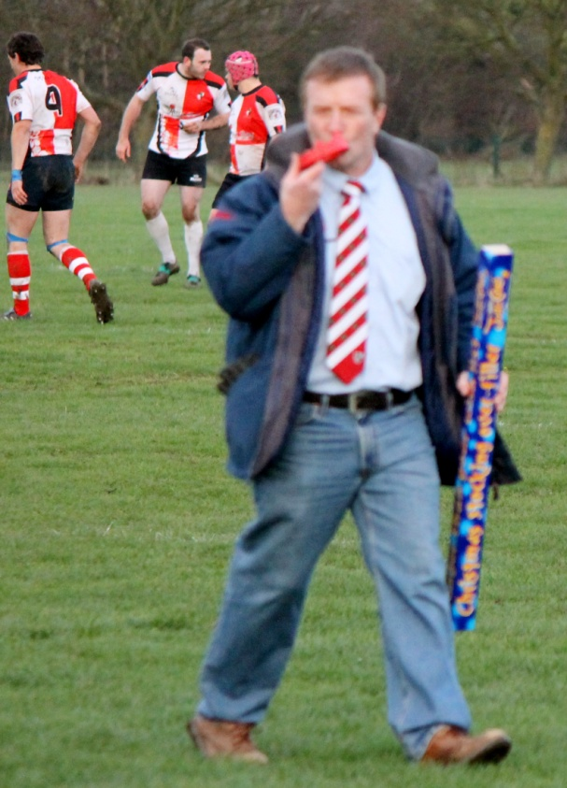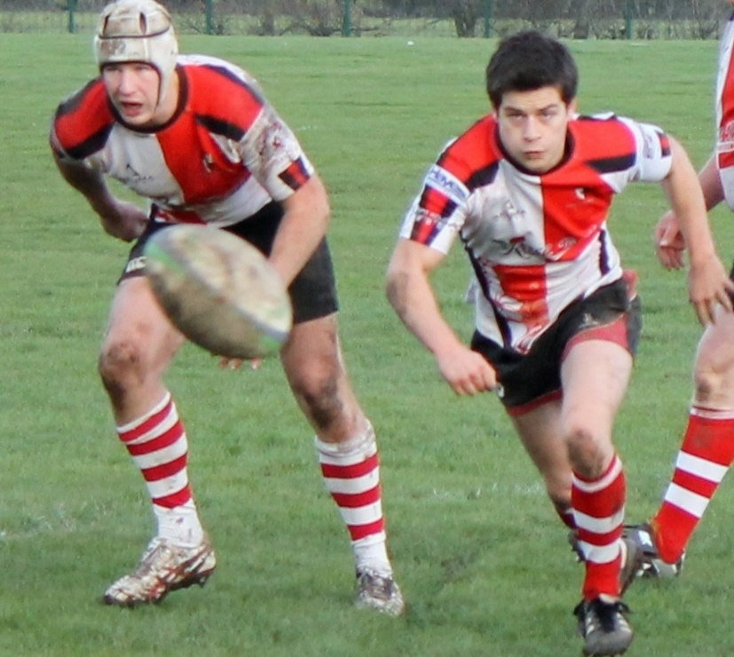
In the first half we saw a lot of movement of the ball out wide. Here's the first try from Martin Woolston, after a lovely set of moves which ended in Shum popping the ball out of the tackle to the ever present Wooly :
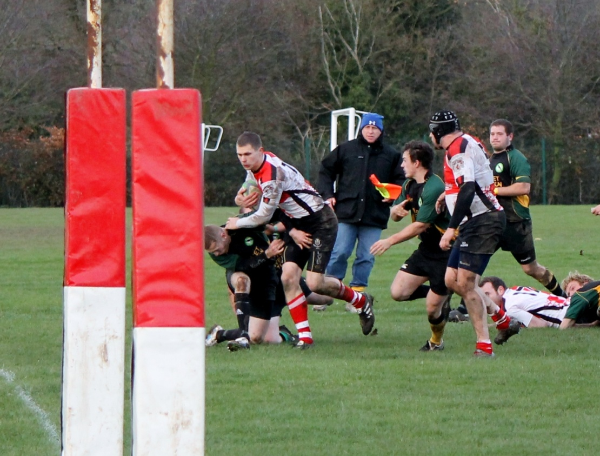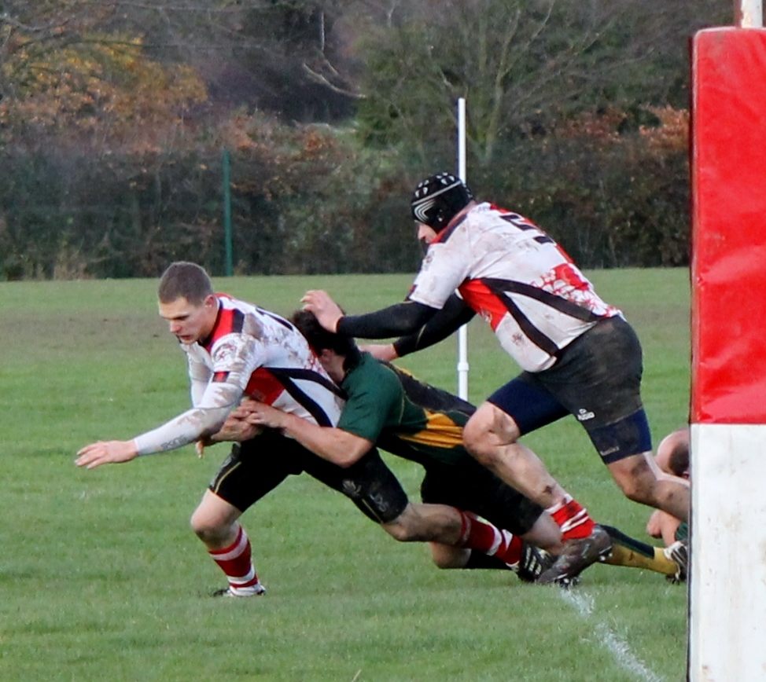
Birdy put over the conversion from Red Red the Tee and although MD had a converted try, we were quite comfortable.
In the second half we saw the forwards dominate our game. Tom Robinson and Matt Bayley were joined by Myles Tydeman who played a stormer - what chance is there of this guy retaining possession here ?
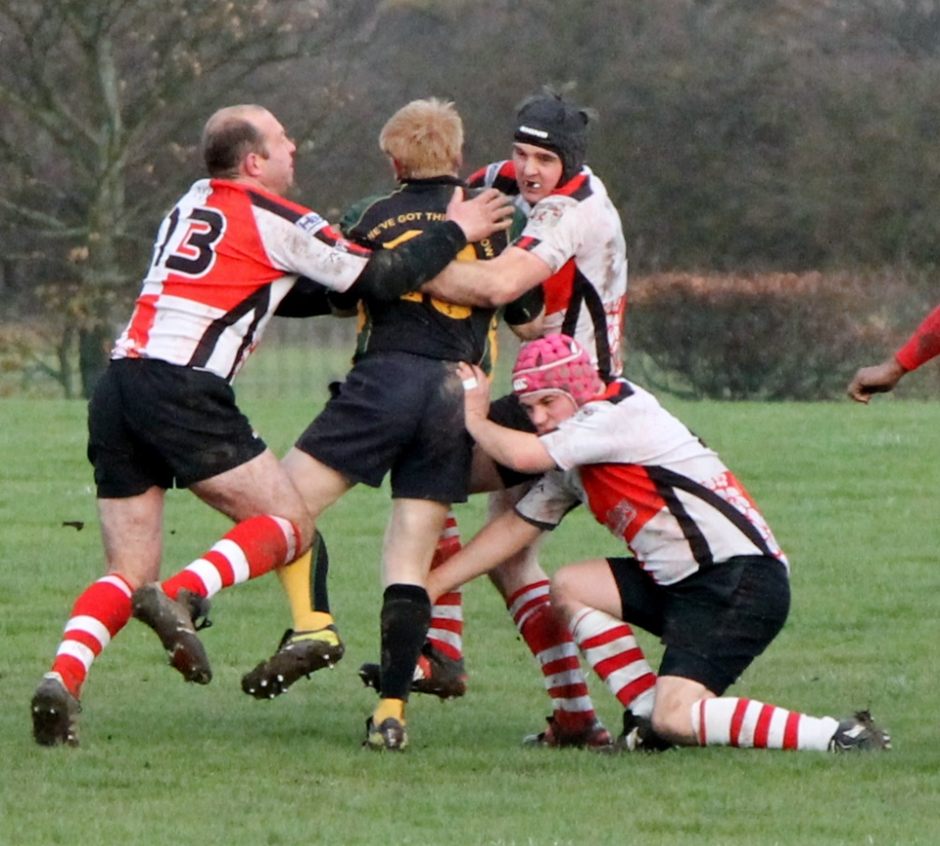
Rowie and Palin locked with Matt Evans coming on later in the game. Newly scrum capped Jonny Simons played his usual thundering Number 8 and Quidditch had good clean ball all day. Craig Hudson came on for Myles late in the second half but it was a very clinical display by Barton.
But it was the second half where Barton came alive. Another lovely try from Ben Murphy finishing off a lovely series of play involving the back row and the backs and the competition between him and brother Sam for the most reliable finisher is still on. Sam and Ben made a lot of yards down the flanks and always drew in the full back for cover, which (when we were able to exploit it) led to overlaps in the next phase. Lovely to watch, frustrating to see when we didn't use them.
And then there was Shum. Time and again he appeared on the wing with the ball looking for trouble and should have had three tries - one he knocked on at the death, one he got bundled into touch and one was the best score of the day. Lovely
So a good win over Market Drayton who had 31 points in third place to our 21 points in fourth place. But with Cannock winning and getting a bonus point they moved above us in the table. Tenbury away next week will resolve this anomaly and the way were played today, it will be an interesting season.

St Leonards 21 - Barton 28 - 3rd December 2011
This was unnecessarily hard. Within 5 minutes we had given them a 7-3 lead and the belief that they could beat us. St Leonards are a bit of an enigma because they have played at much higher levels in the past and have a nice facility in the centre of town, with a nice club house, which is frequented by even nicer ladies from the women's hockey team.
The Rugby boys had done their homework though and were ready for the Barton challenge. They knew we were strong in defence and so played for territory in much of the game. We however chose to do the opposite and five or six penalties were tap-and-go when the obvious decision was to kick for territory. The visiting representative from the Staffs RFU were perplexed with our tactic, especially when seen against St Leonard's defensive strategy. What was that? Well any time we went into contact they double tackled the player and threw many of their quite mobile forwards into the breakdown. A risky approach if it doesn't work because you leave your self exposed to overlaps and on many occasion we had overlaps on both sides but the ferocious battles at the breakdown meant Lee Coton rarely saw clean ball and when he did, it was never quick. Our backs were becoming impatient with the slow ball as many a looping overlap move had to stop, regroup and start again as the scrum half didn't have the ball. This stuttering loss of momentum raised the tension of the backs and when the ball finally did come out we were a little rushed and impatient and knock-ons ensued.
My God there were a lot of scrums. We thought the St Leonards pack would tire against the solid might of Tom Robinson, Matt Cox and Matt Baylesterstar, with the bulk of MBUK and Palin locking the tight five, but to be fair to the home side they used the five sub roll-on-roll-off law to good effect and remained fresh. Credit to the Barton pack who remained unchanged throughout and won that moral victory. Scrums were solid and St Leonards used the roll-on-roll-off law to good effect for the back row and stand offs too as they were pummelled every time by a rampaging Jonny Simons. He always had two or three tacklers slowing down the release but you could see he relished the contact. And what can we say about his flankers ? Pow Pow and Thorpey. Highly effective in very different ways - if they were in the medical profession Thorpey would be the brain surgeon - very precise, technically perfect and blindingly efficient. The patient wakes up feeling great and doesn't' really have many after affects on the rugby pitch it is the same (except the after effect is that the opponent is on the floor and doesn't have the ball any more). Never misses a tackle, technique immaculate, and never gets hurt. Pow Pow would be a battlefield surgeon from the Napoleonic wars where swift drastic action is required. Swash buckles into the theatre, knocking over anything in his path; "Doctor, musket wound to the thigh!" squeals the Nurse "Saw ! Scalpel ! " shouts Pow Pow as he removes the soldier's leg, his left testicle and the right index finger of an assistant in a 23 second operation. A red hot branding iron sears the open wound, and Pow Pow pats the shocked soldier on the head, knocks back the anaesthetic brandy that he forgot to administer to the patient earlier, gooses the nurse on the way out and takes the door of it's hinges as he waves "adieu !" to all. Yes, when you've been tackled by Pow Pow, you know full well what happened.
So these are the guys that make up our forward pack. Matt Cox rampaged through the tight and relished the feel of bone against bone and one on occasion missed the contact and burst out into the wide open spaces of the paddock. Like a young deer flushed out of the sheltered undergrowth and into a dangerously exposed clearing Matt ran left and right and eventually found safety and security of the try line and thankfully flopped over the line with his muckers for company. Birdy missed the conversion but we were back in the game.
St Leonards had added a penalty and so we did the same and it was 11-10 to us. Jan Cleary was starting to get into the game properly. Wooly changed his style of play (straight hard line of running, into contact) and Jan loved this as he was always there looking for the ball, looking for work, looking for his teammates. If it wasn't for the very effective loose play by the home side our backs would have had many more points, and the disappointment showed.
Then came the move we had been waiting for for so long. One of the many rucks started with JS peeling off a scrum but this time the ball was quick. Miss pass to Wooly who was on fire today and loved the straight line contact - boom through the two centres he went, feeding the resurgent Polly who waited and weighted his pass to Sam Murphy who is clinical when it comes to finishing moves. Birdy converted from the special red tee - not orange red but Red Red. 20:20 vision was needed to see the ball sneak over the cross bar because the referee didn't signal whether the conversion was good or not and just blew the whistle for half time.
Then came some surreal events. Louie Whiting was playing on the right wing for Barton and his brother Shaun was locking for St Leonards. Their mum was on the touchline eating all my chocolates when Shaun went down with what we thought was a knee injury - he was not happy, and later tests showed a broken tibia. Just like Cliffy I thought.
Penalties were put over by both fly halfs and then another by St Leonards. And then they scored a try! 21-21 as the light started to fade. We were nervous as we watched the conversion drift wide, but then we got a break - All the backs were involved again and Louie was free down the right hand side but a covering tackle from the St Leonards left wing took Louie down and next thing I see is him being dragged off the pitch with a broken tibia. Can you believe it ? What would the odds be in a Pakistani-cricket-no-ball-betting-scam on that event ? You can imagine the conversation with the Ambulance guys ;
Us - "Whiting, suspected broken leg, Rugby at St Leonards".
Hospital - "Yes, we've got him here"
Us - "No, this is another one".
On came Schumacher and in a tense last ten minutes we saw St Leonards set up an "Occupy Barton" encampment on our 5 yard line. Like the protestors opposite St Pauls in London we weren't sure why they were there, or how long they would stay but we were very, very sure what they wanted. Barton dug deep and the legendary defence kept out the hordes. Eventually a break came and with virtually all the team involved we freed Schummie up the wing to dot down under the posts in the dying minutes and with Red Red Birdy slotted the conversion to conclude the game at 28-21.
Fourth in the league but ten points shy of the guys in 3rd place and only goal difference keeping us above a resurgent Cannock. The rest of the season will be interesting.

Barton 31 - Rugeley 5 - 19th November 2011
The villagers triumph again!
The banter had started long long ago with a Sky sports video clip of Martin de Ridder from Rugeley holding up a sign that said Barton = Village. The suggestion that Rugeley (a Town) should overcome Barton (a village) was never going to faze the Barton team and with a full squad of Veterans playing alongside them on the John Taylor fields it was going to be a tough afternoon for the visitors.
Overall it was a tedious match to watch as Barton were so dominant that any Rugeley attack was quickly snuffed out by the legendary Barton defence. The back row of Simons, flanked by Mercury Cox and James Thorpe were never going to see many people get past them and with Lee Coton at scrum half and Matt Bloxham and Jamie in the centres it was clear that any foray over our gain line was going to be hard fought and well deserved. The tackling was ferocious and effective but never flustered, and watching Thorpedo track down Flint and bring him to ground with almost no effort was a thing of beauty to behold.
The best try of the day was from Ben Murphy who finished off a lovely move involving all the backs and showed everyone present how to generate, maintain and exploit a one man overlap. The lines of running, the timing of the passes, the draw of the opposite number and the accuracy of the hands was a joy to watch and there were very few dry eyes on the touchline after that try was scored.
With Wooly on the right wing and Louie Whiting at full back any attempt at Rugeley kicking for territory would be punished with a siege gun of a boot kicking the ball upfield and when it came down to earth a few minutes later, Wooly would be there with Birdy and his cohorts in tow to keep the ball in Townie territory. Wooly scored a try in each half and another by Matt Cox gave us a comfortable lead of 31-0 after about 55 minutes. Mark Mills and John Ovendin came on to experience a resurgent Rugeley who felt that they had worn down our pack and could resurrect the game. They hadn't and they couldn't as the front row of Tom, Bayley and Huddy with Dave Rowe and the increasingly impressive Matt Evans locking, were simply taking a few minutes rest before resuming their domination of scrums, and mauls, and lineouts and rucks.
Rugeley managed to score an unconverted try in the corner late on in the game and the jubilation seen from the team and the supporters reflected the effort that was required to breach the Barton goal line. We were not happy at losing our clean sheet but the post match Ali Umpa resonated down the Trent Valley all through East Staffordshire as a warning to all.

So as we progress through the season, we see a couple of the favourites stumbling and falling but the Barton machine continues to churn along and we sit comfortably fourth in the table of eleven as we roll into the dark days of winter. Bring it on.

Clee Hill 13 - Barton 13 - 12th November 2011
A long way to go but what a score! First time we've played the Westerners and not lost so a great result away from home.
The Match report and photos are courtesy of Stewart "Statto" Cox:
Arriving in the metropolis of Clee Hill fifteen minutes before kick off after a gruelling two hour drive the hunger pangs struck so it was off to the chippy for sustenance.
"Whats your finest pie Chipmaestro?" I asked. " I can highly recommend the Pukka Meat and Potato Deluxe your Strangership"---deal done.
Back on the touchline Water Boy Ben Blagrove was awaiting kick off. Looking round I said "am I the only spectator ?" he said "yes, and I am the only sub!" Oh Oh! As I started a discussion about the team Ben said, " Mr Cox I cannot take you seriously with pie crust stuck round your face." A sad loss to the Diplomatic Corps was our Big Ben.
With the heavy battle tank tight five formation of John Hutchinson, Matt Bayley, Tom Robinson, Dave Rowe and Mike Bennet and a back row consisting of Rob Smith, Darren Mitchell and Captain Courageous Johnny Simons, Ben and I could tell that the impressive looking Clee Hill pack were in for a gruelling war of attrition.
The half back pairing of Matt Bird and Lee Cotton and centres Mercury Cox ( what half wit parent would call a son Mercury ? ) and Martin Woolston looked aggressive and formidable.
The rear gunners of Kevin Denver, Jody Carvell and Matt Knight promised to cause Clee some anxious times on the wings too.
Shortly after kick off the first scrum was to show how strong a pack we were up against. I know we were at the lower end of a thirty degree slope but it looked like the ref had told only one team that it was uncontested scrums and our pack had taken to the field in carpet slippers as we were shunted back five meters.
Ben and I (now crust free) looked at each other fearing a long hard afternoon. this couldn't go on and thanks to some fantastic team work and magnificent individual performances it didn't.

Now as I have a vested interest in that I have three adopted sons in the team namely, Dave Rowie Cox(" I don't have a table for two") Matt Birdy Cox and Mercury Cox (MERCURY??!!) any match report I would write could be accused of bias--Johnny--- so I will hand over to Mercury to tell the tale of " The Battle of Clee Hill"
"We shall not flag or fail. We shall go on to the end. We shall fight in Shropshire, but we shall not fight in the Shoes or the Shoulder, we shall fight with growing confidence and growing strength in the league, we shall defend our Village (because that is what we are), whatever the cost may be. We shall fight on the beaches, we shall fight on the landing grounds, we shall fight in the fields and in the streets of the village (because that is what we are) , we shall fight in the hills; we shall never surrender."
Clee Hill's pitch and clubhouse had been transformed (on the face of it!). The pitch had become lush and green and suited to the Barton Villagers fast paced running game. Someone who looked like Kev Denver but was not Kev Denver because Kev Denver doesn't play rugby, gave a pre match talk that must have started a few fires in the pit of the stomach that we wanted to give all we could in repayment for those who had lost their lives for ours and who are still putting themselves in harms way for us today like our own personal Squaddie fullback Matt 'Buckaroo' Knight and flyboy Chopper Gillett.
From the off we were fired and ready but our scrums were taking a knock to the big Clee Hill pack. It took time for the front row of Big John, Baylester and farmer Tom to start upsetting their handsome opposition...but they did and with the added thruster power from Mikey B who has not grown into a beautiful swan but a regular Sebastian Chabal partnered with thruster Rowe!
The Back row consisted of the Matty 'work ethic' Evans, Johnathan 'mention me in the match report' Simon and Robert 'hero' Smith. Who tackled and ran hard at the solid Clee Hill defence. Lee Coton who just ruined his opposite mans day and Birdy who took blood with his size 10! After a fast set of play which saw the ball travel from Coton to Bird to Johnny Simmons to POW POW to Baylester who did a sidestep!!! Which ended up with us taking quick ball for Bird to crash over the line and convert his own. Now this is a little hazy as there have been events this week clouding my memory. Such as the defeat of Danny 'Chess King' Carlin by chess novice Cox!
But this match was unfair to go without a report of sorts. So there were some tries and stuff and a couple of those kick things. The word of the day was defence. A superb effort from all the harshness of our defence turned it over and allowed us to attack. The guy who looked like Kev who actually referred to himself as 'Big Dogg' under the high ball, would have been signed up straight away if Kev were there to see it! The mighty Oak and Wooly used there speed to carve through the defence and produce a great performance. The lonesome sub was take over POW POW as he rested his bloody face and produce a fine performance of I am too strong to move!
So pretty weak on the detail but a mention needed for all. A superb performance for Barton Village (because we are a village) and a really good strong opposition who I look forward to welcoming to the Barton Village.....Barton Thunderdome.
You ask, What is our policy? I will say; “It is to wage war, by sea, land and air, with all our might and with all the strength that God can give us: to wage war against a monstrous tyranny, never surpassed in the dark lamentable catalogue of human crime. That is our policy.” You ask, What is our aim? I can answer with one word: Victory—victory at all costs, victory in spite of all terror, victory however long and hard the road may be; for without victory there is no survival.
lest we forget, And we are a Village Thunderdome!!!
End Report
This was without doubt the best defence game Barton have played this season. Clee threw absolutely everything they had at our boys and they were repelled time and time again. Unfortunately with only one substitute and the super human effort that every one had put in we were unable to hold onto the win at the very end.

There was no " Man of the Match" for me! Just sixteen of them. Thank you guys it was a privilege to watch this performance.----- " I was there !"

PS Should you ever be in Clee Hill Shropshire looking for a vegetarian delicacy I can highly recommend the Pukka Meat and Potato Deluxe Pie

Barton 22 - Telford 30 - 29th October 2011
I was not looking forward to this game. We had a few people who have played first team rugby this season who were missing this week; Rob Smith, Lee Coton, Martin Woolston, Tom Robinson and then a massive loss of Matts - Matt Bird, Matt Bloxham, Matt Cox, Matt Perkins, Matt Knight. I looked at Telford's record; played five won five, conceded 26 points. Ooooh I was worried. We are good in defence but my God, playing five games with an average of five points being conceded makes any defensive coach puff their chest out with pride.
The game was at home and due to an extended pre-match warm up in the Shoulder I was pitchside five minutes late. We were 8-0 up and the sour faces of the Telford travellers said it all. Ben Murphy had gone over in the corner and Jamie had just kicked a penalty and the possession and passion was all from Barton. Harry and Jan were the centre partnership and despite having a combined age less than mine, they set up in defence and planned attacks like they'd been playing for decades. The tackling was led as usual by Thorpey who inspired the whole team to snuff out any suggestion of a rout from the league leaders. Telford's game plan was clear - their number 8 was big and fast and he was the main ball carrier and go-to guy when things got difficult. We learnt last week that if you let a big forward build up speed then you are always going backwards and the four try stinging that the Edwardian lock gave us last week meant that within 90 seconds Barton had devised a game plan to stop the Telford 8 from gaining any ground. This slowed the game down immensely but only if we could keep up the tackles.
The nice standoff with a trendy pink undershirt ran the backs well, but again we quickly saw that he was not a runner or a tackler and so our back row made a bee line for him when we had the ball, and in defence we completely ignored him knowing he could only kick or pass. At one point when Jamie's kick to touch was collected by Steve Dixon on the touchline, the Telford ten tried to take a quick throw in. Steve told him he couldn't because the ball had been touched by a spectator to which the reply was "I'm not stupid you know". Steve's reply of "well did your Mum choose that top then ?" had all the spectators laughing.
Rowie wasn't laughing. He had a match long tussle with a lanky lock playing 16 and after one lineout in front of the massed crowds a little scuffle ensued. The Telford lock threw and landed a punch which everyone saw, including the ref, and he decided to yellow card both players. By this time we were 15-10 up after H scored a lovely try after a period of sustained pressure, and Jamie duly converted. Our front row of Bayley, Huddy and Big John played well and with Rowie and MBUK locking, it was a surprise to see our scrums disrupted so much by the visitors. The visiting spectators told us that their forwards were much more dominant in previous games and that they were frustrated at not being able to boss the set pieces over here in East Staffordshire, so our guys should be proud. Daz Mitchell and Jonny Simons completed the pack and saw far too many Telford players running at them with the ball for comfort.
With Rowie and their lock sitting out the end of the first half, Telford had a bit of a resurgence and their 8 peeled off the back of a ruck and went blind, giving Murph no chance with the speeding overlapping winger as he had to come inside to tackle the big man. The half ended 15-15 and the crowd, fuelled with curly wurlys, white chocolate and raspberry cookies and Dalmore whisky, were excited. Telford had never led this match and had conceded three times the number of points they were used to, and their supporters were worried. Barton's "Shed" were vocal and excited at the prospect of a big upset.
At half time I asked the Sky Sports team what the tackle count was, and what percentage possession Barton had in the first half but JC just gave me a glazed look and said "purple". Sam Murph had to come off with a flattened foot and Neil Forden came onto the wing. Big John came off with a flattened foot and Cliffy went on. Cliffy ran about for a bit, broke his fibula and hobbled off demanding that I hand back the kicking tee ! Cheek of the man ! Deano had to go on, as did Dave Palin when MBUK came off - are you still following me ? Huddy came off for a while and Mark Mills went on and so the rolling of five substitutes was complete.
Telford liked the rolling mauls as well as the pick and drive from rucks and managed to score an unconverted try early in the second half after a simple penalty. We were 23-15 down. Telford marched on and we carried on defending, breaking downfield every now and again to the immense frustration of the Telford forwards. The rucks were not for the faint hearted and many a player was "encouraged" to move with a Shropshire rake, and the crowd were not pleased at this tactic - this was our brand new flowery kit remember, and we didn't want it soiled.
Eventually the referee decided that Barton were slowing the ball down a little too much and pinged Jamie for ten minutes at a ruck on the far side. Unfortunately this ten minutes allowed Telford to increase their lead with another forward led try that this time was converted and at 30-15 and a man down we were not as happy as we were 40 minutes earlier. Barton's defence was solid all game and despite being a man down, the structure and strength remained and many lesser sides would have buckled under the onslaught that Telford threw at us during these ten minutes.
Big Louie at full back had a quiet game as the kicking from their standoff was deep and accurate so the ball was either well into touch or Louie had plenty of time before the hordes arrived. But it was Quidditch who won man of the match for slowing down the Telford back row long enough for his cavalry to arrive and snuff out their attack. It really wasn't to their liking and during one of their mauls the Rowe/16 tussle continued and one of the Telford back row decided to headbutt Palin (I know we've all been there). He missed, but the referee didn't miss the intent and their number 6 saw a straight red card from the East Yorkshire referee. With 14 men on the park, Telford couldn't keep up and we quickly dominated the game from then on. Unfortunately there wasn't enough time and although Dave Palin scored a try which Jamie converted we lost 30-22.
The league is now very interesting. Telford, Edwardians and Market Drayton sit on top with 5 or 6 wins from 6 games, then there are Rugeley, Bishops Castle and Tenbury at the bottom, but the middle five of Barton, Cannock, St Leonards, Bloxwich and Clee Hill are all within three points of each other. Our only losses have been against the top two teams and there is nothing in this league that we should be scared of. Just look at the league leaders and what five other teams have scored against them this season - Clee Hill 5, Rugeley 3, St Leonards 5, Market Drayton 10, Tenbury 3. Then along come Barton and roll 22 points past them. This will be interesting.

Edwardians 53 - Barton 5- 22nd October 2011
As we strolled through the poplar lined avenues of Solihull, squinting into the low autumnal sun, I wondered what Edwardians rugby club would be like. They've been around since 1882 which is just over a hundred years longer than Barton, and I expected a deep, rich history, ancient traditions, and a strong ethos for the true spirit of our wonderful sport. How wrong I was. Barton lost the game but we haven't lost the meaning of Rugby which has been AWOL in B92 for many years.
Edwardians were perplexed at the start, and after five minutes they had looked us up and down and this is what they saw; tight in the middle, clear patterns and structure, a few new names, and nothing like they expected having surveyed our website. I was also perplexed with our new kit. It was tight in the middle (except when Kev put on the XXXXXXXXXXL number ZO shirt), the patterns and swoopy lines gave me a headache and the new sponsors names were there for all to see. But it was the flowers that did it . Yes, like Giles and Mitch, I have a penchant for musical theatre, and I have been know to recite poetry whilst rubbing Hazel blossom between my fingers, but the flowery patters on a loose head prop is somewhat incongruous, even to me. I decided that if we could win in this kit we could win anywhere. We didn't.
The crowd perched on the high bank were confused as Steeny kept shouting "come on Reds" which to the players sounded like the muffled support from the locals who squeaked "come on Eds". But the banter on the field was even better.
The game was stopped for a quarter of an hour while everyone discussed "unnecessary roughness", and a threat from the home team to take the ball and stop playing. There were suggestions of eye gouging which we all know is not how Barton play, and I can only imagine what the Eds would have made of Bloxwich's tackle on Jamie earlier this month which passed off without a murmur from either side.
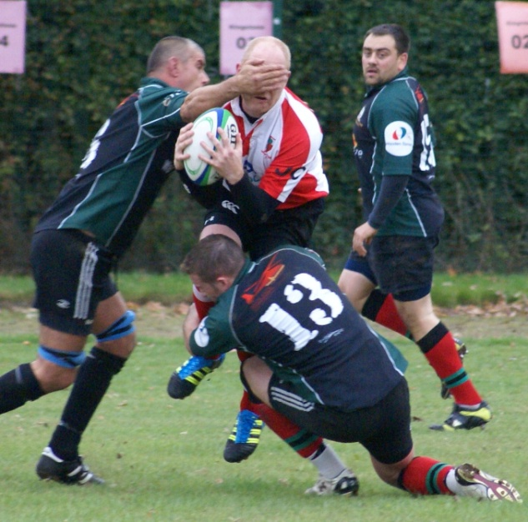
The game was played at a ferocious pace and the home team tried hard to bring in their big winger on every play. He should have scored more but failed to look for support and dropped a few too. He should have scored less because we shouldn't have given him the space, but we were poor out wide in defence. Sure, I'm being harsh, but Barton are not known as a side that wins easily, but a side that is hard to beat. After Saturday I'm not so sure.
The officials refereed out the physical contest and there were times that it felt like a slow game of touch, which the big back row from Edwardians took advantage of, blundering through our tackles with ease. We were slow up in defence and missed Lee Coton's charge up to the line as we sat back on the gain line and let them come to us.
But that wouldn't have been enough to give Eds a win. We would have to let them dominate the set pieces too; and we let them. There was an 18 minute period where we lost every one of our lineouts and scrums, and when we were awarded a penalty in our 22 we had to tap and go because any other option would simply give them good possession and territory. Tough day for a Captain. It came together a little later by which time the game had gone from our grasp, and I thought the pack played well today; Mikey B deservedly getting the Man of the Match award from the second row. With Bayley/Huddy/Coxy and Cliffy rotating round the front row we had a strong tight five with Dave "missing first aid bag" Rowe locking against MBUK. Coxy's powder blue "Daisy Roots" danced around the place, desperate to join his rolling back row colleagues that comprised Jonny Simons, Thorpey, Fradgley, and Pow Pow. The way Thorpey rose in the lineout suggested we should have won more ball from the set pieces but it was not to be, and it never quite gelled. Blokko's venture in the centres ended with an Aaron Cruden type knee bump and a smack on the jaw opened up Pow Pow's chin nicely (and Barton were accused of being rough ?!). So the forwards had a decent day at the office, even if they struggled to stop the rampaging Edwardian 4 to 8 in open play.
The backs were poor by our standards. It was enough to make me want to throw myself off Aukland Harbour bridge. The Edwardian full back was a decent player but that was it, and I know Barton are better than every other back on show today, especially their excitable number 19 who needs to calm down and learn how to drink beer. I went to Solihull wondering why Edwardians were playing so low down in the league but anyone seeing Barton for the first time today would have left wondering how we were so high in the league. I mean listen to the names: Knight, Maxwell, Bird, Bloxham, Woolston, Murphy, Murphy. These are the names that strike fear to teams in this league, but in sleepy, softly Solihull we couldn't make it work.
Edwardians have a long history and that is fine and dandy; lion hearts they are not. The soft lily white hands of the Edwardians tight five showed me that life in Solihull is kind and gentle, and that a different genre of Rugby is played here. None of us were surprised when we were asked by a scared pack member if Cannock and Bloxwich were rougher than Barton. "Don't worry petal, you'll be fine" said Steeny, a little tongue in cheek.
But in the end we lost and lost badly. Coxy's early try was the end of a nice piece of work but I hate October. For some reason we never let people score more than 50 points against us unless it is mid October;
- Worst loss in 2008/09 - St Leonards 47-14 on 4th October
- Worst loss in 2009/10 - Cleobury 60 - 6 on 17th October
- Worst loss in 2010/11 - Bloxwich 55 - 3 on 9th October
- Worst loss in 2011/12 - Edwardians 53 - 5 on 22nd October
Stop it !!!!
We have a tough fixture against league leaders Telford next Saturday, so get down to training, work on your moves, and bring back the Barton that we know and love, and let's end this October on a high.

East Retford 38 - Barton 17- 15th October 2011
It's a long way to Retford, and even further on the way home when you lose. We hadn't planned to be playing this weekend as the RFU in their infinite wisdom decided to keep the EDF cup fixture dates a secret and therefore lots of our players were expecting a free weekend and were missing. I arrived at the ground to see our boys 10-5 up after a penalty and a penalty try but Retford were running wild and the 20 minutes either side of half time was almost embarrassing. "They were much better before you arrived" said Kev Denver and Stewart Cox. The front row of Sutty, Bayley and Cliffy were backed up by Mikey B and Matt Evans and the tight five looked secure. The back row of Tabs (welcome back big man), Pow Pow and Coxy were never short of experience but the Retford pack were very mobile and very soon I was sick of the sight of their big second rows blundering about the field in open play, ball in hand, wondering what the hell to do next.
The half backs of Quidditch and Bird were no strangers to their respective positions and with Wooly and Louie Whiting in the centres we knew there was not a lot going to get through there; so Retford chose to generate overlaps and attack the wings. Matt Evans and Sutty had this wonderful ability to look like they were not sure where they should be but knew exactly where they needed to be to frustrate and flummox the Retford attacks. A gentle slap on the ball in a ruck from Matt and a gentle tug of a jersey from Sutty were all that was needed to spoil Retford's attack. This freed up Coxy and Cliffy to cause havoc anywhere they chose to roam and as worn by all good Gareths, Cliffy's white shorts were prominent at every breakdown, alongside some shocking blue boots (Coxy - that colour blue should only be worn as an off-the-shoulder dress in a cocktail bar).
I tried hard to slow down the home team replacements by feeding them marshmallows and jelly babies, but marshmallows only work in certain circumstances and the only people who like the jelly babies were those who'd already been substituted. I must try harder.
Josh Billings ran about like a demon (as he always does) and just after half time Jody came on to replace him and probably saw more action in those 30 minutes than in any full game he's played in. Murph and Polly completed the backs, and it was clear from the "oh no, not again" look on Polly's face as yet another Retford flanker bore down on him, that this had been the game so far. As the second half wore on we started to snuff out the Retford threat and stop them from scoring. We started to gain possession, then territory and gradually build momentum. Their lineout on their five yard line. We were through quickly and they had to touch back. Scrum, feed the backs, Wooly and Louie take hard lines, draw in defence, ruck, and out pops Pow Pow to thread Pocock / McCaw like through the gaps and under the posts. Beautiful. Bird converts from the special tee (Red Red is always special) and we feel on top. Whoop Whoop. Two converted tries and we're into extra time.
Wooly came off and so did Tabs to let Daz Mitchell and Dean Fradgley come on and the pressure mounted again. With ball in hand Barton looked threatening and the Retford defence was splintered and sporadic. At the breakdowns there was always some drama with the ball on the floor, being booted upfield, being passed Queens Hospital, Ward 3 like to the backs, or being handled on the floor. The ref had a good game and kept everyone informed of his thoughts, and I'm sure he felt as we did that in attack Barton were steady and controlled, while the Retford defence panicked a bit but still made the tackles when they needed to be made.
When Retford had possession it was a beautiful sight to behold. They were well drilled, their backs kept very deep and ran sublime lines off their stand off, and their back row fringed the rucks like the wisps of foam spray on the crests of a wave. Boy, would I have been pissed off having done all that and to not rack up 60 points. But they were playing Barton. Not Barton's regular first 15, but chose any 15 from the Bars camp and they would behave the same way.
We are a fit bunch and our defence is well known in Midlands West North 4; it is now well known in Midlands East North 4 too. It was great to see Louie back and it was great to see Bayley's try-saving tackle on the lock in the last five minutes, but it was not great to see Travis go down in the last play of the game with a neck injury. Polly never followed my example of lying on the field for a rest or the stop the clock so my teammates could, or to slow play down to dull the opposition momentum, and so when he stayed level with the neatly trimmed Bermuda grass we all got worried. Thanks to the guys from Retford who called the ambulance (O2 hasn't made it that far into no-mans-land) and who helped get him into the ambulance and thanks to the paramedics who heard my plea not to cut off his shirt as this was the only kit we were ever going to have that everyone liked.
So we lost. Bugger, But I have to doff my cap to those guys who stepped up from the second team to take on a very well drilled Retford side, and to assume the mantle of the Barton style of First team rugby. We are not flamboyant or flippant, we don't take massive gambles and draw "ooohhhhhhs" from the crowd that often, but we are fit, well organised and bloody hard to beat. Retford's coach said in a somewhat surprised tone " the scoreline flattered us because you guys are well organised in defence and patient in attack". Yes, he is from a different area and yes he was surprised, but I wasn't, and neither was anyone else who's seen the red and white quarters play in 2011.
Good job guys.

Barton 15 - Bloxwich 22 - 8th October 2011
Typical. Just when I mention a winning streak, we go and lose a game that we shouldn't have. Much like the English national team but without the dwarf scandal. Steve Dixon reports again :
A Leopard Never Changes its Spots

Barton Rugby Club is full of players with individual flair, a good mix of youth and experience and an energy rarely seen in these parts. When all of these components combine in a collective team effort the results are formidable. To date, this season, this Barton team has indeed been formidable.

With confidence high, a Bloxwich team sat at the bottom of the table, due to a combination of a points deduction owing to last season’s indiscretions and having only played one league match, we were all looking forward to another formidable display.

Matt Cox was away at a Freddie Mercury Convention in Buxton (a Leopard never changes its spots) so Dave Palin came in at Lock with Mike Bennett and Dave Rowe moved to blindside. Matt Bird was away on a Gay Pride trip from Doneghal to Belfast with Irish Ninja Tours (a Leopard never changes its spots) so young Jan Cleary came in for a debut appearance at outside centre.

Barton started down the slope with the wind behind and opted for a tactical kicking game to gain territory and try to keep Bloxwich in their 22. Bloxwich were proving to be very strong at the scrummage (a Leopard never changes its spots) and the game had started as somewhat of a kicking dual with the ball pinging from half to half.

As the game settled down, Jamie Maxwell placed two clever kicks down the flanks for Woolly to run onto but he was just unable to reach the ball and the wind took the ball to touch or through the dead ball area.

The Bloxwich set piece was providing a platform for what appeared to be a new set of backs at 10, 12 and 13 and they started to play some good running rugby. The Barton defence though were proving as strong as usual and despite lots of possession for Bloxwich, it was Barton who put the first points on the board.

Jamie had put the ball into the corner from a penalty and from a driving maul Rowie scored a try (GROAN), which Jamie could not convert from wide on the right wing. Barton 5 Bloxwich 0

Matt Knight took a nasty bang to the head and had to leave the field as a blood injury and was duly replaced by Quidditch. Bloxwich made good ground and with a four man overlap they decided to take the ball on and the Barton defence forced a knock on. The Barton scrum was becoming more effective and the game was proving to be a great spectacle.

Hold on ! ! Bloxwich playing in a game of rugby that was proving to be a great spectacle? ? Maybe a Leopard does change its spots! !

Woolly made several good breaks but was unable to break the defensive line or set up one of his support runners and whatever Barton adopted seemed to just not quite be coming off. Matt Bloxham was giving another fantastic performance at open side and started to get some of the Bloxwich players rattled and then he tackled their 12 and ripped the ball to turnover possession but again it came to nothing. Possession was being kicked away too often when our main threat was when we kept ball in hand.

Knighty, who had returned to the fray with a stocking on his head, was penalised for being offside and Bloxwich added the points from a penalty. Barton 5 Bloxwich 3

Now it would appear that Leopards from Bloxwich tend to wear number 15 on their back, and that the definition of the word Leopard in the Bloxwichian Dictionary translates to T*ss*r.

The signs had been there the week before at Bishop’s Castle. Barton have a tendency to play as individuals rather than in a collective team effort against weaker teams. As a result, they become less effective and therefore not as ruthless as they should be. This same trait began to shine through today (a Leopard never changes its spots) but against a stronger team they were more likely to be punished. Just before half time the Bloxwich 10 and 12 combined well and for the first time in the game Barton missed tackles and allowed the 12 in to score under the posts. Barton 5 Bloxwich 10

This seemed to spark Barton into action and with the last play of the first half Matt Bloxham gained 20 metres with a strong run before passing to Lee Coton and when Bloxwich infringed at the ruck Jamie put over the penalty.

Half Time – Barton 8 Bloxwich 10

The wind had strengthened and as the second half started it was plain to see that the Barton tactic was to keep ball in hand and work up the slope, which they did effectively and set off strongly. Bloxwich used the following wind to pin Barton back every time they won possession and so the pattern of play continued. Barton were getting frustrated as their skilful handling, which gained hard ground, went to waste time after time due to unforced errors.

Then Bloxwich scored two soft tries, the first one coming from a school boy error in defence for Barton. Barton 8 Bloxwich 15

The second one was quite remarkable. The referee gave a penalty to Bloxwich from 8 metres out following infringement at the ruck and the Bloxwich 8 tapped and went, from a position behind the referee and not where the penalty offence had been committed to put in his support runner. Barton were asleep and should have been more alert. Barton 8 Bloxwich 22

Big John Hutchinson was then yellow carded for a late tackle on the Bloxwich 8 and commented – ‘everyone’s a w**k*r’ ! ! I was bemused that he knew the surname of the opposing number 15.

This appeared to galvanise Barton and their character and team ethic at last started to shine through. The handling and support play that followed was exquisite and with Jan Cleary in particular having a fine debut. The ball was worked out to Woolly on the wing who was tackled just short but not held and when he went again he managed to ground the ball for a try only to be denied by another remarkable refereeing decision – Held Up !!!!!

From the 5 metre scrum Jamie received the ball and threw a dummy (he learnt that from Gary Bentley) before driving forward to score under the posts and convert the try. Barton 15 Bloxwich 22

The Bloxwich forwards were tiring, fractious and started to get niggly (a Leopard never changes its spots) and suddenly it was Barton with the ascendancy. Barton worked phase after phase of play and put the Bloxwich defence under intense pressure.

In the last minutes of the game Barton had worked the ball into the Bloxwich 22 and with a 2 man overlap on the right wing Sarah came from nowhere at pace, which comes natural to this out and out winger turned lock, to take the crash ball. He took 3 players with him over the line and like all naturally talented wingers (Chris Ashton and Sarah) he went for the beautifully executed ‘Swan Dive’ – and dropped the bloody ball.

Final Score – Barton 15 – Bloxwich 22

So only a bonus point gained and in the words of out Captain -
‘They weren’t good; we were poor, individually and collectively.’

Never a truer word, but this is a sign of how far we have come in 2 years. Expectations are high and with 3 teams Barton are looking strong.

A mention has to go to Jan Cleary for a fine debut but man of the match has to go to Matt Bloxham for yet another awesome performance !

A LEOPARD NEVER CHANGES ITS SPOTS !!!!!

Bishops Castle 0 - Barton 32 - 1st October 2011
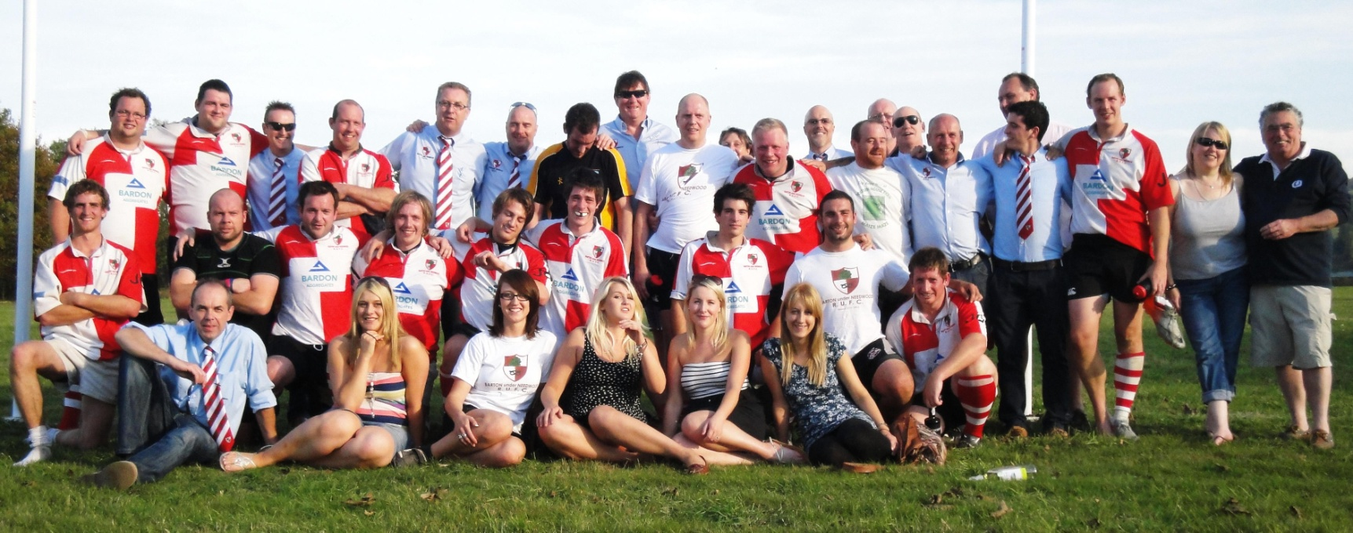
The juggernaut rolls on. Waiting for photos and match report, but in the meantime, savour the score and the fact that Barton haven't lost a game since 19th February. That's 12 games and 225 days without a loss. Not a bad winning streak.
Here's what Steve Dixon saw :
BARTON BASHES THE BISHOP !!!!!!!!
The masses gathered at the Shoes, the Full English was good, the Scots did what they do best and dominated, competed, then, of course, ‘LOST TO ENGLAND’ ! ! !
The Saxons rejoiced, ‘Big Yin Niall (Havering Big Galloot)’, ‘Wee Coxy’ and ‘Lovely Aileen’ took on the typical Celt attitude of – ‘AH WHAT THE FECK, LET’s HAVE A DRINK TO COMMISERATE’ !
The First XV Squad arrived, the WAGS arrived, Roomy arrived (with her new beige patent medic bag) the coach arrived and we departed for Bishop’s Castle at 11.30 am for what would prove to be a great away day ! !
The white wine flowed, the Septio flowed, Mick the Driver looked concerned and after 2-hours we arrived for lunch at The Three Tuns, Bishop Castle. Whilst the 1st XV went to find the pitch, the beer flowed, more wine flowed, the Burgers were impressive and the coach picked us up. Then came the phone call.
‘No running water at the pitch – 28 degrees of heat’
Rearrange these letters – ‘SCLOBLOK’ – FYT and Rummers were off to find the Spar. So, after walking a mile with half a ton of water in transit we finally arrived at the match 20 minutes after KO and the Barton team looked, hot, bothered, thirsty and were leading after a Matt Bird Penalty – Bishop’s Castle 0 Barton 3.
The pitch was uneven, dusty and hard and covered in dried sheep shit. The dust made it difficult to see what was happening but Barton appeared to have most of the play and were ripping into the Bishop’s defence.
Then Lee Coton took the ball on and tore through the Castle to score under the posts. Birdy converted and it was – Bishop’s Castle 0 Barton 10.
So it remained until half time.
As I pondered the second half I noticed a few things.
· There were lots and lots of tractors by the pitch.
· A sheep auction was taking place about 50 yards away.
· And most worryingly, on his first Rugby trip with Barton, my mate Neil ‘Sven’ Hall had gone missing.
Now Neil ain’t no Rugby man, he’s a football girl and the ladies love him, especially his lovely lady ‘Jax’ who he had promised to take out that evening at 7.00 pm sharp. As i said, Neil ain’t no Rugby man.
The setting was lovely and then I made the mistake of stating that Barton, being located in rural Staffordshire, had little in common with Bishop’s Castle. And so started the comments of the smart arses that we love so much at Barton: -
Craig Hudson – ‘I used to be a farmer, Big John Hutchinson is a farmer and Tom Robinson is a farmer’.
Bill Scroggs – ‘My Uncle used to have a farm in Devon’
Rich ‘Bevvy’ Bevan – ‘I used to own a digger’.
Roomy – ‘Rowie snores like a pig’
Gary ‘Bentos’ Bentley – ‘I drink milk. In fact I once bought 6 litres of milk and got a free Baby’s Rattle and matching Baby’s Dummy’.
Stu ‘Statto’ Cox – ‘One of the lads got carried off after a kick in the balls last week. He had two acres’.
Then from out of the dust and sunshine appeared my mate Sven, tan winkle pickers, gelled hair, Armani jeans and £300.00 leather belt. Thank God I thought, until he came out with the line – ‘The Sheep auction is interesting’- FFS Sven !!!!
The second half kicked off and I have to admit I can’t remember much about it but I do remember Birdy sitting in the pocket waiting for the drop goal when we won another penalty and he duly kicked the points – Bishop’s castle 0 Barton 13
Sven was asking if anyone had any signal so he could check the Blades score – Ben Murph obliged – 0-0 Sven, what do you expect.
Barton started to take control and create good phases and patterns of play. Matt Cox took the ball on to feed Matt Bloxham and when Lee Coton set up a ruck Jamie fed Birdy for Sarah Palin to shred through the defence and score under the posts, from which Birdy converted – Bishop’s Castle 0 Barton 20
It was difficult to concentrate, Sven had wandered over to talk to the WAGS and so I felt the need to go and ask if they were all ok. Bad idea !!!
Aimie Cox – ‘The toilets have got nettles in’
Xantia (i think) – ‘There are no chairs or gazebo’s’
Lucy ‘Harrow Gate’ Fozard – ‘Where’s the Champagne Bar ?’
Becky Lodge – couldn’t even get her words out as she looked at Sven in admiration as he stared off into the sun drenched distance dreaming about Jax, The Blades, Shandy and Sheep !!!!
The ball came out to Blokko who was having another great game and he kicked on before out pacing the covering full back to score. Birdy converted – Bishop’s castle 0 Barton 27
From the kick off Barton again created some fantastic phases of play before Sarah set up a ruck 10 metres out. The ball ended up with Coxy near the right wing and he put in Travis to score the bonus point winning 4th try in the corner. Birdy missed the kick (how unusual) and it was – Bishop’s castle 0 Barton 32
Just before the final whistle Cliffy, back from injury, attempted a drop kick off his ‘Dominoes Pizza’ sponsored belly, which was interesting.
But....
Not as interesting as the sheep auction as my mate Sven asked – ‘Guess how much a sheep costs’?
We don’t know Sven !
‘£240.00’ he replied !
‘How’s the Blades getting on’?
‘Are we leaving in a bit’?
‘What time is it’?
The ref blew his whistle for full time and it ended – Bishop’s castle 0 Barton 32
Man of the match – Matt Knight
Woman of the match – Sven
So the celebrations began and what great hosts from a lovely little town and based at a great local pub in the Boar’s Head. The beer flowed, the wine flowed, the Treasurer (Louise Philpott) had a dig about Gareth’s BO comment, the Bluegrass music down the road was err well....different...and off we set for home.
We stopped off at the Mermaid to Dream about a beautiful Bride and the wine flowed and the beer flowed.
Jim Steinman serenaded us, there were Bats out of Hell, Dashboard Lights, Folk doing anything for love...but not that, and then Rowie asked the question.....
What have the Barton Rugby team and the Scottish Rugby team got in common – they are both on their way home.
Carnage followed, wine flowed, beer flowed, port flowed and cheese was consumed but we all got back safely and the lost property list from the coach read as follows:
- One Rugby Sock
- One Pair of Pierre Cardin Chino’s
- One Barton Dress Shirt (without pocket)
- One Barton Dress Shirt (with pocket but without any front left panel)
- One Black Leather Camera Bag (including camera)
- One Humongous Picnic Basket (Niall you owe me one, Kim would have killed you)
- One Matching Baby’s Rattle and Baby’s Dummy set.
- And Sven – where the flick was Sven !!!!!!
Barton win again, The Blades lose again, Sven is late again and next week it’s Bloxwich at home !!!

Barton 36 - Atherstone 20 - 24th September 2011
“You vill vait to cream bolly” he said.
“Huh ?” I replied.
“Sorry” said the English head waiter, “My colleague was trying to tell you chef has dropped your crème brulee and you will have to wait until he makes another one”.
It was almost English but this was a restaurant in Northern Germany. Earlier that evening as I swept through the lush Hannoverian forests I had marvelled at the competence of the German people. They are very good engineers, good at sports, can control their economy and make the trains run on time. They build lots of very good cars (all of which are dark blue or black around here), dominate the machine tool market and are a byword for Quality in manufacturing circles. They have won many, many Olympic medals both summer and winter varieties, and of course have won three world cups at football. They are single handedly propping up the Euro zone and struggle to understand why the Greeks, Italians and Portuguese still hate them (try wearing an England shirt in Sauchihall street mate). It’s not all rosy though. The Germans can’t fight properly (we’ve won both world wars remember), they can’t speak English properly, and they are rubbish at Rugby.
There must be a lot of Germans in Atherstone.
Here’s Steve Dixon’s match report to fill you in on the details.
As has become tradition, the ‘Codgers Under Needwood Team Support’ met for pre match refreshments in a local hostelry and the press team of Statto, Scroggsy, The Count and FYT (that’s me by the way) met for a pre match briefing. It turned out that The Count had gone to the Bath v Gloucester game on a scouting mission and so it was left to me to report on today’s match.
Fresh from an impressive first league game the week before, when Barton comprehensively beat their old adversaries Cannock, today, Barton faced an unknown force in the Cup.
Atherstone play at the same level as Barton in Midlands 4 West South and so the game was going to be an interesting contest.
Barton, without their regular half back pairing of Quidditch and Jamie Maxwell, lined up in their changed strip, which is the same as the Argentineans’; Atherstone lined up in all black which is the same as the, well, All Blacks, the referee was sporting a nice little cerise number for such an athletic frame and JC watched from the sidelines in matching Plum cardigan and training shoes.....it promised to be a colourful day !!!
Matt Knight filled in at 9 and Matt Bird at 10 with Neil Forden coming in to the outside centre slot and with Barton looking ready and confident Atherstone kicked off. Barton were quick to get into their stride with good rucking, fast ball and quick hands. After only 59 seconds (thanks Statto) Atherstone conceded a penalty for infringing at the ruck 30 metres out, and from in front of the posts Birdy struck a good kick only for the wind to hold it up.
The game started in a frenzied manner with both teams trying to get on top. Matt Bloxham was proving to be a real problem for Atherstone and likewise, the Atherstone 9 was sharp and proving to be good opposition.
Following some sustained pressure on the Barton line it was Atherstone that drew first blood as their 9 picked and went from the base of the ruck to score after 8 minutes (ta again Statto). The conversion was well struck by the Atherstone 15 and it was Barton 0 Atherstone 7.
Bloxham was quick off the mark and caught the restart then gained good ground before off loading to Matt Knight who popped to Jonny Simons. The support running was impressive and from a ruck 15 metres out the ball was fed to Birdy who turned the defence with a grubber kick only to be cynically tripped by the Atherstone 6. Birdy missed the kick and after 11 minutes (Statto) the number 6 was asked to take a 10 minute rest by the Cerise clad referee.
The 22 drop out was blocked and again Blokko pounced to take the ball on and feed Craig Hudson in the tackle. Unfortunately, Huddy did a fantastic impression of Ben Kay and knocked on when only 1 metre out.
From the ensuing scrum the opposing 9 box kicked clear but he wasn’t to know that this tactic is bread and butter stuff for our back 3 of Ben Murphy, Sam Murphy and Travis Perkins. Bensam caught the clearance and fed Samben who off loaded in the tackle to Blokko for him to score under the posts. Birdy found his kicking boots and struck the conversion just like JC’s matching cardigan and trainers....PLUM !! Barton 7 Atherstone 7.
Barton were enjoying the majority of the play and the Atherstone forwards were starting to show their frustration as they struggled to cope with the speed and aggression of the Barton pack. Barton became dominant in the scrum and the front 3 of Huddy, Big John Hutchinson and Matt Cox (who was showing an incredible resemblance to a ‘Fat Freddy Mercury’ with his new tash) were proving to be an outstanding combination.
Atherstone started to introduce the dark arts and the younger Barton side were falling for it. It was at this juncture that one of the more experienced members of the Codgers Under Needwood Team Support shouted some good advice to his lad, Matt Bloxham. ‘GIVE HIM A SLAP MATTY’ referring to the Atherstone 7.
This was soon to be followed with some good advice for the man in errr, cerise. ‘IF YOU DON’T SORT THESE RUCKS SOMEONE WILL GET THEIR HEAD CAVED IN’. Evan never ceases to amaze us with his Rugby wisdom at Barton and he is rarely proved wrong.
Atherstone now started to disrupt Barton’s play with some unsavoury incidents off the ball and following a series of good phases they scored a second try, which the 15 converted impressively from out on the far touchline. Barton 7 Atherstone 14.
Lee Coton tackled the Atherstone No 10 and forced him back 15 metres only to be illegally shoulder charged in the ruck by the opposing No 15. Lee had to leave the field and on came Martin Woolly Woolston to slot in at outside centre with Neil Forden dropping in to inside centre.
The game calmed down for a period and Rob ‘Pow Pow’ Smith took the ball on before kicking into space and finding touch 10 metres out. The 9 again box kicked clear and on went the same pattern of play repeatedly.
Barton were then awarded a penalty for another infringement at the breakdown and Birdy decided to complain to the referee about the colour clash between his cerise shirt and JC’s matching Plum cardigan and trainers, which had distracted him and led to him missing his first two penalty kicks at goal. The referee wasn’t impressed, reversed the penalty and the Atherstone 15 again converted the kick to 3 points. Barton 7 Atherstone 17.
From the restart Blokko again made good yards and set up a ruck 15 metres out. The ball was fed to Neil Forden who put in a smart grubber for Woolly to run onto but the Atherstone 15 just beat him to the touch down.
Barton were a bit frantic and with Birdy playing out of position at 10 he seemed to be forcing the play rather than letting his natural instinct and ability make things happen. However, he must have been reading my thoughts as Barton gained possession of the ball and he threw a miss pass out to Woolly who drew the defence before putting Sam Murphy in to finish. Birdy converted and it was Barton 14 Atherstone 17.
Pow Pow took on the restart and fed Jonny Simons but we were deemed to go over the top at the ruck and the opposing 15 slotted the penalty to bring the score to Barton 14 Atherstone 20 at halftime.
Half Time Barton 14 Atherstone 20
Sam Murphy (knee) was replaced by Dave ‘Sarah’ Palin on the wing, Lee Coton and Coach Kev handed out some steadying advice at the half time team talk and with the slope and wind in Barton’s favour confidence was high.
Pow Pow took the ball forward and after some incredible off loads Blokko scored for Birdy to convert. And make it Barton 21 Atherstone 20.
I must apologise at this point as I didn’t really see the build up to this try due to me watching big Neil Forden being filled in off the ball by his opposite number – you can take the lad out of Lancashire but you can’t take the Lancashire out the lad (sorry Neil) !!
There were several more unsavoury incidents off the ball with Atherstone losing discipline and the game went through a scrappy spell again. Barton didn’t only stand up to this but they kept their cool and kept playing rugby. The Barton scrum dominated and with Mike Bennett and Dave Rowe at Lock we were only going in one direction – FORWARDS!!!
Atherstone were tiring now and on came Matt Bayley at Hooker replacing Neil Forden and with the ‘Fat Freddie Mercury’ that is Coxy moving to inside centre.
Birdy put another 3 points on the board following yet another infringement at the breakdown to bring the score to Barton 24 Atherstone 20.
The next phase of play was of the highest standard. Big John secured good ball at the restart and took 3 players out of the game as he popped the ball to Dave Rowe. Rowie has matured beyond belief of late and drew his marker before feeding Coxy who fed Woolly. Woolly is quick, strong and getting better tactically. He cut an inside line taking 2 defenders out of play and popped to Sarah Palin on the wing. Now Sarah cusses and spits at training ‘cos he doesn’t like running – however, ball in hand and tryline in sight and he is like a charging Rhino. Under the posts he went, Birdy converted, Barton 31 Atherstone 20.
Unfortunately, Evan’s prediction was nearly proved right at the next ruck as we had to witness an incident not welcome on a rugby pitch. ‘Fat Freddie Mercury’ took the ball into a ruck after beating 3 defenders only for the Atherstone Number 18 to inflict what we decided was a ‘Homophobic’ stamp on Coxy’s head. Coxy was out cold for a few seconds and had to leave the field. The number 18 also had to leave the field as the red card was flashed by the man in cerise. Let’s hope he learns his lesson after a lengthy ban.
In the final minutes of the match the Barton forwards took a ball against the head at the scrum from 5 metres out and Jonny Simons scored to make the final score Barton 36 Atherstone 20.
So, an impressive start to the season and a great victory against a team that engaged unsavoury tactics but this Barton team is better than that and they stood toe to toe, played great rugby and won the day. Our set piece is looking solid, the fitness throughout the team is high and confidence is up. I for one can’t wait for our trip to Bishop’s Castle in the league next week – well done Bars !!!

But in the end, there are no Germans in East Staffordshire. We speak perfect English without the gruff, coal-dust enhanced East Midlands twang, we haven’t annexed part of Leicestershire and called it North Warwickshire, we haven’t started a fight without provocation, we do fight honourably and victoriously, and we can play Rugby.
We are part of the civilised society.
We are Barton.

Barton 27 - Cannock 12- 17th September 2011
What ? ! Where’s my milk ? ! ? Call me anal if you want but at 10:00 on Saturday mornings I have to have full fat milk on my Crunchy Nut Cornflakes, strong freshly ground coffee and 30 minutes peace to do the crossword. It’s a long standing ritual and one I do not relinquish lightly. This morning the milkman had left two bottles on the doorstep as usual, but today something,....... SOMETHING, had pierced the foil tops on the bottles, removed the cream layer and according to my know-it-all wife, rendered the milk unusable as it was now “sour”. What ? ! Where’s my milk ? ! ? I reiterated, but to no effect.
My whole world had fallen apart and her soothing tones of “it’ll be alright” quickly morphed into “it was the birds” to “pull yourself together you great wassock”, but none of it mattered; I didn’t have my full cream milk because some bird, some thoughtless creature had cruelly robbed me of it. I trundled down to the Co-op and bought some milk and partially restored some semblance of order to my shattered existence. It was 12:00 now and soon my mind turned to the afternoon’s encounter against Cannock.
It was always going to be a tough encounter with our Nemesis. The two league games last season were only a score apart and wins were shared, but of course we had beaten Cannock in the Owen cup final, but our seconds had lost to their seconds last week. Which way would it go today ? Barton's two pre-season friendlies were dominant affairs at 69-0 and 73-0 but the real test is when we play in a real competition and with a real referee. Still unable to shake off the trauma of the morning’s events I watched a Barton team ruthlessly dissect our West Midlands rivals.
It started well With Big John and Huddy in the front row and Matt Cox sandwiched in the centre, our scrums were solid and the heavy Cannock pack were not going to spoil our day. Mikey B and Rowie in the second row. meant the set pieces and lineouts were always going to be reliable affairs.
And before long, Birdy scored a lovely try - so good that England's Manu Tuilagi copied the Barton move to score against Georgia the following day. I have of course complained to the authorities about our secret set moves being stolen by Martin Johnson et al, and asked for recognition and compensation, but the Ombudsman at the Commission for Undermining New Training Schemes was no help at all.
Birdy converted and soon we were back scrummaging on their 5 yard line when the back row decided to pick & go blind and there was Jonny Simons smiling with ball over the line, thankful for the presence of Bloxham and Pow Pow. Birdy didn't smile as he had a right hand touchline conversion to make; but he did. Quite nice. The pressure and the gentle breeze helped keep us dominant in the first half and Ben Murphy touched down to finish off a fine move with the ever present Matt Perkins for company. Again Birdy converted and all of this was done with Matt Bloxham sportingly sitting our for ten minutes behind the posts in an effort to make more a game of it for the visiting Cannock supporters. Sadly for them their team were unable to capitalise on the extra man and the half ended 21-0.
By now the touchline sweets and Bill Scrogg's sloe gin had all but disappeared and as word got around more and more of the Barton population came down to savour in the match. The second half was a little different as Cannock managed to score two tries with only one conversion, but we kept the scoreboard ticking over by slotting two penalties. We didn't need to panic and just needed to protect our lead and run down the clock - good strategy from the captain and coach in my view but frustrating for the Cannock side.
The backs were solid today and even the partisan Cannock press said our defence was awesome. Man of the match Jamie marshalled Lee Coton and Birdy in the centres and with a Murphy on each wing and Polly securing the full back slot it was going to be an easy day for them. Quidditch had good clean ball all day thanks to the Barton pack, and it bodes well for the future. Pow Pow and his new headgear got pinged a few times for what can only be called "over-enthusiastic tackling" but that's just the way he plays, and long may he do so.
We didn't use any subs but what a bench to chose from ! Thorpedo, Gillet, Cliffy, all praying for a small injury to one of the back row, and at 21-0 up I think most of the assembled crowd fancied a run at the shaky Cannock backs. As you expect from a proud team, the niggle started to show and the visitor's frustration became a little too much for the Cannock 9 and his stamping in the first half, (oh, and again in the second half ref), his petty duel with Quidditch and his complete inability to control the forwards bubbled up at the sixty minute mark. We drew lots and it was down to Rowie to combine a tackle, a trip and a tug of both ears, which although executed perfectly, was well within view of the ref and David took a ten minute rest. Cannock still couldn't score which incensed the scrum half even more and the baiting continued.
Overall a tough encounter as you would expect. The pre-season training and the set move practice paid off as we knew it would, and the fitness of the Barton team (none of whom tired and needed replacing) showed who would be top dog in the old Staffs I league today. The game however was played without serious conflict, apart from one guy trying to provoke a reaction from the boys in red & white.
So it wasn’t the first time that day that things had gone sour due to an annoying little tit.

